Food security in the atoll countries of the

South Pacific - with particular reference to  
Tuvalu: A Report prepared for IFAD to  
assist in the preparation of

funding proposal to the Global Agriculture and Food  
Security Program

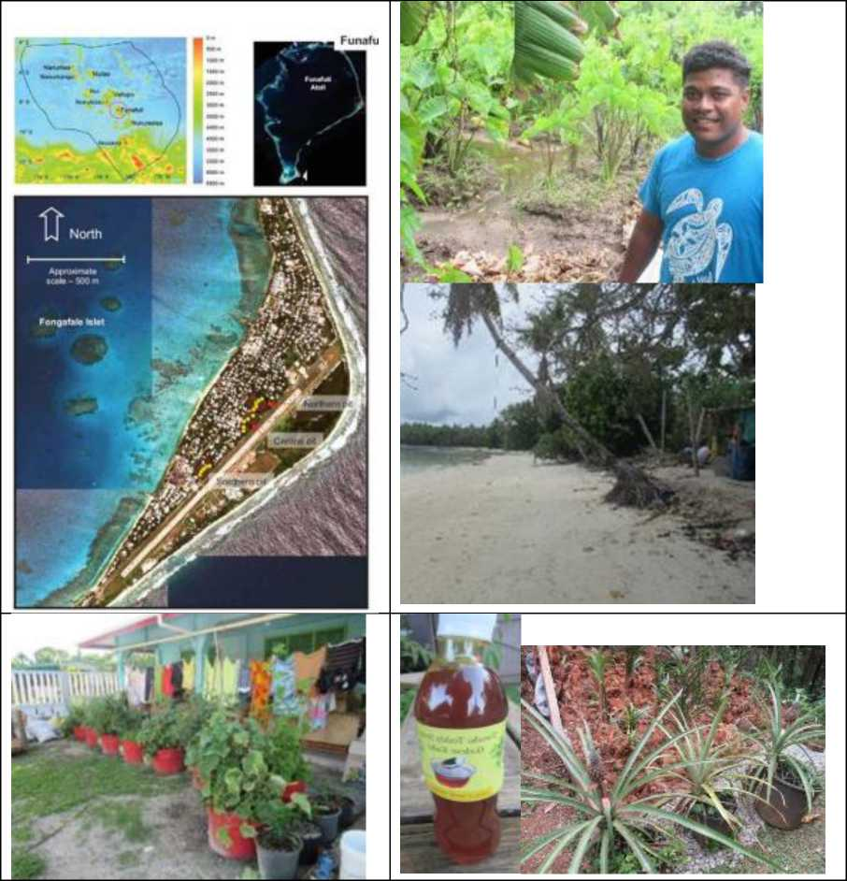

**Prepared by Andrew McGregor with Mark Sheehy**

Table of Contents

1. Atolls in the Pacific Islands region 4
2. The impact of extreme climatic extremes and change on the atoll countries 7
   1. Tidal extremes 7
   2. Extreme droughts 10
3. Atoll countries capacity to adapt to climate extremes and change 12
   1. The adaptive capacity of crops and cropping systems 12
      1. Coconuts 12
      2. Breadfruit 13
      3. Pulaka (swamp taro) 17
      4. Taro (colocasia) 18
      5. Kumala 18
      6. Cassava 19
   2. Assorted traditional crops (pandanus, banana laulu etc.) 19
      1. Introduced fruit and vegetables 20
      2. Processing and food preservation 21
   3. Demographic trends 23
   4. Food preference and the incidence of NCDs 24
   5. Kiribati 31
4. The Tuvalu case study 38
   1. The food that is consumed and its cost 38
      1. Imported food 38
      2. Rice, wheat flour and wheat flour products 38
      3. Sugar and confectionary products 40
      4. Edible oil 41
      5. Edible meat 42
      6. Beverages and spirits 43
      7. Vegetables 43
      8. Dairy products 46
      9. Fresh fruit 46
      10. Fresh seafood 48
   2. The food that is produced locally 48
   3. Coconuts 50
      1. 3 Self-sufficiency from coconuts 50
      2. Cash income earned from coconuts 52
   4. Root crops 52
      1. Self-sufficiency from root crops 53
      2. Cash income earned from root crops 54
   5. Breadfruit 54

54

* 1. Introduced fruit and vegetables 54
  2. The marketing system for locally produced food 55
  3. Advantages and disadvantages for local food production 56
     1. Advantages 56
     2. Disadvantages 58

1. Recommendations for improving food security in South Pacific Atoll Countries with emphasis on

Tuvalu 61

* 1. A concerted coconut replanting program as part of developing appropriate agroforestry systems involving breadfruit and the other traditional fruit tree crops 61
  2. Onsite training in traditional agriculture - with a focus on the youth living in the outer islands 62
  3. Training in traditional food preservation and appropriate “modern” food processing methods 62
  4. A concerted effort to test and distribute the climate resilience of available root crop germplasam provided through SPC 62
  5. A concerted effort to promote home garden production on Funafuti 63
  6. Development of a viable sustainable value chain for outer island producers to sell their products (particularly root crops) in Funafuti 64
  7. Undertaking an agriculture and food production census for Tuvalu and Kiribati 64

1. Atolls in the Pacific Islands region.

Atolls are defined as low coral islands that lack volcanic or continental rock in their surface geology. An exception is the raised atoll of Niue. From an agricultural point of view, they are one of the harshest and most vulnerable environments on earth. The classical atoll has circular or semicircular reef surrounding a lagoon, in some cases they are just low reef islands, rarely more than a few metres above sea-level that consist mainly of loose rubble and sand.

**EU ECf SOPAC RwAwg AGP States Tmratu - Sa^aly** *n **smmp** to.n -

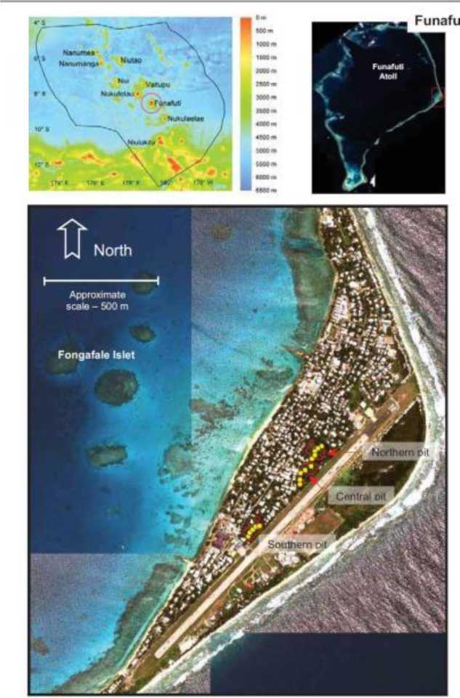

Atolls have mostly formed in warm waters close to the equator. Pacific island atolls lie in clusters or chains that run in a south-eastern direction from the Marshall Islands through the Gilbert group in western Kiribati, to Tuvalu, then Tokelau, to the Northern Cook Islands, and to the Tuamotu Archipelago in French Polynesia. The atolls states Kiribati, Tuvalu, Marshall Islands, Tokelau and Niue, the last being a raised single coral island - are some of the world's tiniest nations (Table 1), yet some are spread over vast areas of ocean. Some other Pacific island micro-states, namely Cook Islands, Federated States of Micronesia, French Polynesia, and Palau, are a combination of atolls and high islands. Most other Pacific island countries have a few inhabited atolls, such as the northern islands of Tonga, the southern Lau group in Fiji, Ontong Java in eastern Solomon Islands, and parts of the Manus and Bougainville group in Papua New Guinea. Some of these inhabited atolls are densely populated such Ontong Java, which has a population of 2,857 (2009 Census) with a land area of only 12 km**2** spread over 122 islands.

*Table 1: The Atoll States of the South Pacific*

|  |  |  |  |  |  |
| --- | --- | --- | --- | --- | --- |
| **Country** | **Population** | **Land area (km2)** | **Population Density** | **GDP (A$'000)** | **Population Growth (Avg. ann percent)** |
| Tuvalu | 11,400 | 26km2 | 448/Km2 | 57,295 | 1.2% |
| Kiribati | 11,300 | 800km2 | 156/km2 | 244,233 | 1.3% |
| Tokelau | 1499 | 10km2 | 115/km2 | 9,184 | 1.2% |
| Niue | 1,624 | 261km2 | 5.35/km2 | 5,800 | 0.2% |

Sources: ADB Key Indicators for the Pacific 2018; ADB Basic Statistics 2019 | | |

Soil development on atolls tends to be minimal due to the recent establishment of sand deposits on reef platforms. What soil does exist is shallow, alkaline, coarse-textured, and lacks most nutrients required for plant growth, such as organic carbon, nitrogen, potassium, iron, and magnesium. The water holding capacity of these soils is very low, with plant nutrition dependent on the humus cycle and the retention of vegetation cover. The atolls have low annual rainfall (usually in the order of 1,500 to 2,000 mm) and are subject to considerable seasonal and annual variability. Low rainfall and poor water holding capacity means that fresh water resources are very limited, with the only permanent supplies being groundwater lenses that are often brackish. Compared with volcanic islands, the permanent moisture stress found on atolls requires highly intensive application of labour if there is to be any arable cropping. As result the return to labour effort from farming tends to be very low. Limited land and water resources and low returns to labour effort puts binding constraints on any form of agricultural development. Thus, the main basis of subsistence is marine products, with supplementary agriculture limited to a few tree species mainly coconuts and breadfruit that can survive growing in virtual sand, high salinity, and water stress. Arable cropping is confined to particular types of root crops grown in compost pits dug below the fresh water lense that lies at the centre of most inhabited atolls. Small scale hydroponic and potted compost home gardens are also seen to play an increasingly important role. The fact that agriculture in atoll countries like Kiribati and Tuvalu makes up a significant proportion of national income reflects their material impoverishment. In recent years the absolute contribution of agriculture to national income has declined further and has been replaced by donor funded public sector expenditure.

These countries have a low capacity to produce food domestically and to generate export earnings. Thus, almost all purchased food is imported, as shown in the Tuvalu case study. Consequently, the Food Import Capability Index (FICI)s**[1] [2]** for atoll countries is very high suggesting that these countries are amongst the most food-insecure countries in the world. For example, the average FICI for Kiribati in the period 2008-2010 was 750%. The outer island communities of these countries are more involved in self-sufficiency food production, with the marine sector being far more important than agriculture. Despite this, resilient crops such as coconuts and breadfruit play a key food security role and will need to play an increasing role in the future if food security is not to deteriorate further.

The main food imports are rice and wheat flour. For consumers these products Rice have a number of advantages compared with the staple food crops of the Pacific. The costs of feeding a family can be cheaper, they are easier to use and store, and have higher concentrations of carbohydrates. However, they usually contain more fat, are more energy dense, are significantly higher in sodium, and contain virtually no vitamins A and C. A comparison of nutrients in 100 g edible portions of boiled taro and rice can be found in the SPC Pacific Food Leaflet on taro, clearly showing the nutritional benefits that can be gained by consuming taro, giant taro and swamp taro (<http://opac.spc.int/cgi-bin/koha/opac-detail.pl?biblionumber=37138>). These crops also contain higher levels of P-carotene equivalent than rice, an antioxidant that has been shown to play an important role in improving protection against cancer, heart disease, hypertension and stroke (Lako et al. 2007**2**). In addition, and importantly, their glycaemic index compared with a food such as rice is much lower, an important consideration for those prone to and suffering from diabetes (Foliaki and Pearce 2003)**[3]**.

1. Lako J, Trenerry C, Wahlqvist M, Wattanapenpaiboon N, Sotheeswaran S and Premier R (2007) Phytochemical flavanols, carotenoids and the antioxidant properties of a wide selection of Fijian fruit, vegetables and other readily available foods. *Food Chemistry* 101, 1727-1741.
2. The impact of extreme climatic extremes and change on the atoll countries

These small fragile atoll island environments are susceptible to events that for larger islands might be relatively minor episodes. The atolls are especially vulnerable to cyclones, drought, and the effects of sea-level rise and El Nino-Southern Oscillation (ENSO) induced extreme tides.

2.1 Tidal extremes

The data presented in figure 1 below for Palau shows that while there has been a steady increase of daily mean sea levels over the last 50 years it is the extreme high tides that present the greatest risk (see figures 1 and 2)

**Figure 1: Palau’s extreme tidal fluctuations illustrated by the daily mean sea level for Koror harbour**

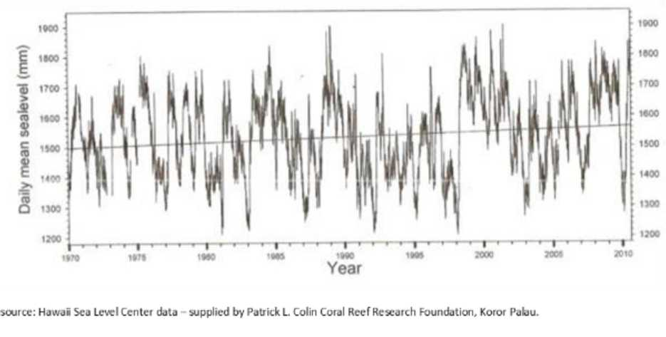

**Figure 2: Monthly tidal gauge data for Pacific island atoll countries\***

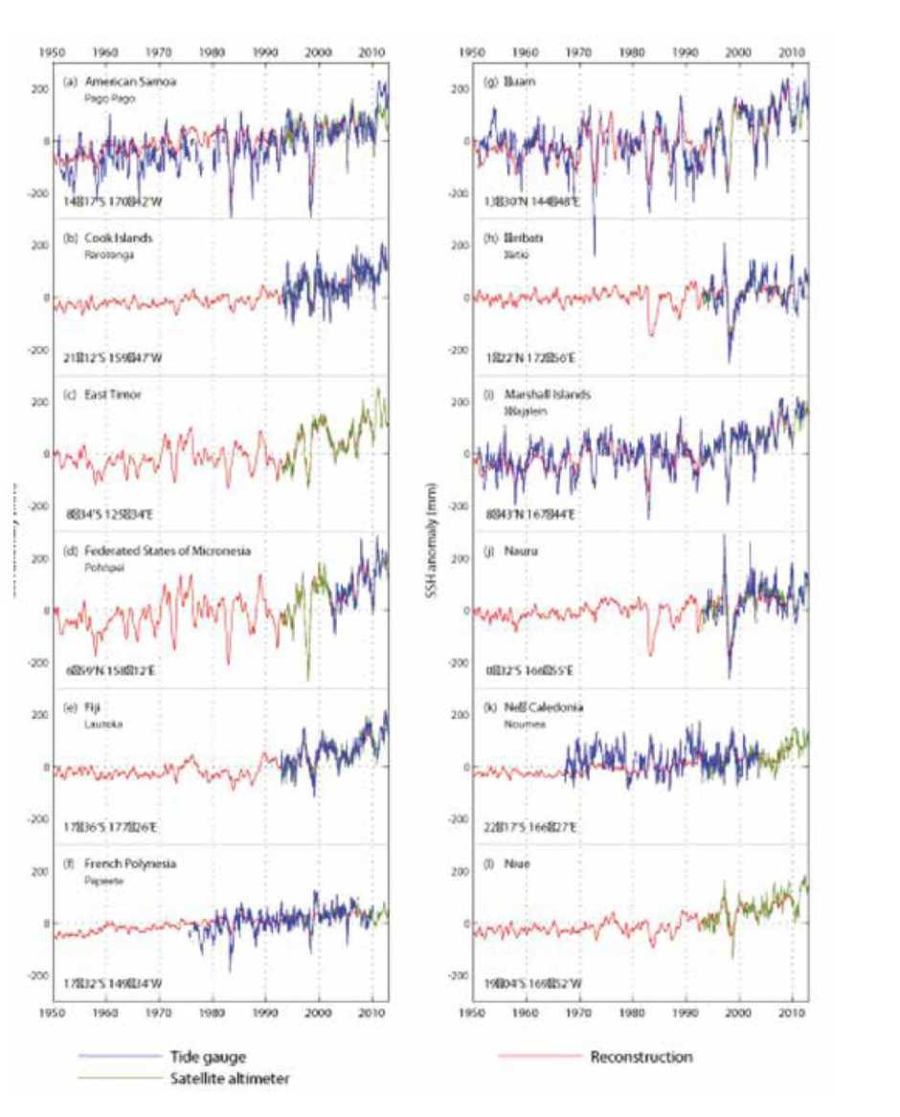

*Source: Taylor et.al 2016 p, 76**4**.

4 Taylor M, A McGregor and B Dawson (2016). Vulnerability of Pacific Island agriculture and forestry to climate change. Pacific Community, Noumea New Caledonia.

[https://www.sprep.org/attachments/VirLib/Regional/vulnerability-pacific-island-agriculture-forestry-climate- change.pdf](https://www.sprep.org/attachments/VirLib/Regional/vulnerability-pacific-island-agriculture-forestry-climate-change.pdf)

Most atolls are located in warm waters close to the equator, the region where most cyclones form. The incidence of cyclones increases away from the equator. Tuvalu, which lies close to the South Pacific convergence zone (SPCZ), where the north-east and south-east trade winds meet in the southern summer, is a prime area for cyclones to form. By contrast, Kiribati, which straddles the equator, is seldom, if ever, affected by cyclones. During an El Nino episode, the SPCZ shifts eastwards, making cyclones more common around the northern Cook Islands and less common around Tuvalu although the cyclones that do affect Tuvalu during an El Nino episode appear to be more powerful as was the case with Tropical Cyclone (TC) Pam in March 2015. TC Pam completely destroyed the pulaka pits on Nui atoll in Tuvalu and they are only now starting to recover**[4]**. Most climate change models predict the although cyclones may become somewhat less frequent their intensity is expected to increase (Taylor et.al. 2016 p, 128) - with the damage caused by cyclones increasing exponentially with windspeed (McGregor and McGregor 1999 p, 6)**[5]**

Atolls may be no more prone to cyclones than high islands of similar longitude, but they are more vulnerable to their impact. All the land area of an atoll and its entire population will usually be affected by a single event. In some places, they are only a few meters wide and everyplace is close to the sea; there is no higher ground to move to, and any inundation affects most if not all of the island. The high waves and sea surges that accompany cyclones can cause the intrusion of salt water into compost pits, contamination of fresh water wells, and erosion of already limited land resources. On high islands, even in the most severe cyclones, significant pockets of land usually escape relatively unscathed. Atolls are never so fortunate. Furthermore, a cyclone that hits a high island weakens as it loses contact with its power source-the sea-but this will not happen over an atoll. On the other hand, the small size of an atoll means there is rarely a direct hit.

Because atolls are only a few metres above sea level at their highest point they are highly vulnerable to cyclone induced storm surges, extreme high tides and the underlying sea level rise. Agriculture is severely impacted with coastal erosion, increasing areas of land under permanent inundation, fresh water lens contamination and increasing soil salination. Soil salinity affects plant growth and survival because increasing levels of certain ions, mainly sodium and chloride in the soil solution effectively decrease water availability (osmotic effect). These same ions can also damage plant metabolism and growth (toxic effect). Salinity also cause nutrient deficiencies or imbalances, due to the competition of sodium and chlorine with nutrients such as potassium, calcium, and nitrogen.

The SPC Book “Vulnerability of Pacific Island agriculture and forestry to climate change” (Taylor et.al, 2016) notes that apart from the atoll countries and the atoll islands of the larger Melanesian countries sea level rise, extreme high tides and storm surges are not a major problem for the region in terms of agricultural production. However, for the atolls extreme high tide and storm surges are identified as the major issue for food production. To quote:

Although the atoll countries are highly reliant on food imports (see Chapter 9), the cropping systems of countries such as Kiribati and Tuvalu, particularly in the outer islands, continue to make a valuable contribution to household self-sufficiency despite the difficult environment in which they operate. Salinisation of groundwater, storm surges and land lost due to coastal erosion will make it even more difficult for these systems to supply food to growing populations. Any efforts to improve local food production, such as utilising and possibly processing excess crops (e.g. breadfruit) from the outer islands, will need to take into account effects from sea level rise. As discussed in Chapter 4, increasing salinisation could result in swamp taro production declining in importance in the short term (2030), and possibly disappearing entirely in the medium term (2050) (Taylor et.al. 2016 p 127)

2.2 Extreme droughts

Atolls also tend to be susceptible to droughts, for they lack the natural rain catchments of high islands. Being low and small, rain-bearing clouds often pass right over. Nor are there other sources of water, except on some atolls that have a fresh groundwater lens. Most atolls have annual rainfall of around 1,500 to 2,000 mm. but there is considerable variability between atoll groups**[6]**. There is also considerable year to year variability driven by the ENSO cycle as illustrated by table 2 below. This variability is most pronounced on the margins of the dry belt. Much of Kiribati is particularly affected in this way.

Table 2: Summary of the impacts of El Nino and La Nina on rainfall*.

|  |  |  |  |  |
| --- | --- | --- | --- | --- |
| Country | Region | El Nino | extreme El Nino | La Nina |
| **FSM** | West | Wet | Dry |  |
|  | East | Wet | Dry |  |
| **Kiribati** | Gilbert Islands | Very wet | Dry | Very dry |
|  | Line Islands | Wet | Very wet | Very dry |
| **Marshall Islands** | North | Wet | Wet | Dry |
|  | South | Wet | Wet |  |
| **Tuvalu** |  | Wet | Wet | Dry |

* Taylor et. al p, 65

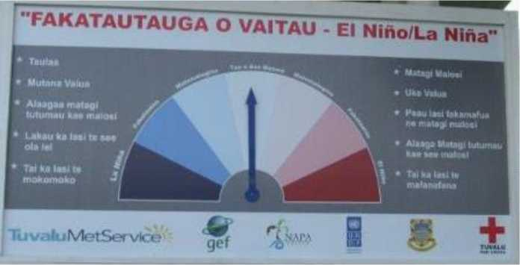

3 Atoll countries capacity to adapt to climate extremes and change

* 1. The adaptive capacity of crops and cropping systems
     1. Coconuts

In coastal locations throughout the Pacific islands, coconuts are of fundamental importance as a staple livelihood crop and for none more so than atoll dwellers. On Tuvalu, an estimated 2,100 ha, or some 70% of the cultivable land is planted with coconut (a high percentage are senile (> 60 years) or self-planted. Coconuts tolerate neglect perhaps better than any other crop. Coconuts thrive in a tropical environment with a mean temperature of 28°C, a maximum of not more than 34°C and minimum of not less than 22°C (Foale and Harries 2011)**[7]**. These are the conditions found in the Pacific atolls. South Pacific tall coconut varieties evolved in cyclone-prone environments and therefore have adapted to survive in the strongest of winds. The most violent winds can uproot or break mature palms, but only young and senile palms are really vulnerable. A major problem facing coconut industries is the ever-increasing percentage of senile palms. For the Pacific overall, this accelerating downward production trend is the consequence of the ever-increasing percentage of senile coconut palms (palms over 60-years old). In the case of Fiji, senile palms were estimated, more than a decade ago by FAO/Asian Pacific Coconut Community (APCC), to account for around 60% of all planted coconuts (Bulai 2017)**[8]**. The situation for the atoll countries Kiribati and Tuvalu is of the same order of magnitude. Since the time of the last FAO/APCC Report, significantly more coconut trees have become senile. However, increasing numbers of these old trees have been lost due to the increased frequency of intense cyclones (in the case of Tuvalu Category 5 Cyclone Pam in 2016).

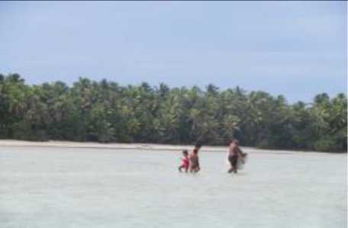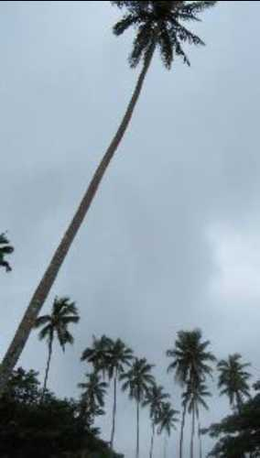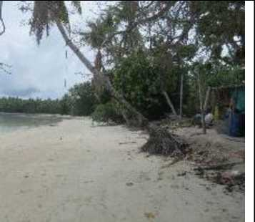

Densely planted coconuts on Funafala island in the Funafuti atoll

A typical senile Pacific tall coconut palm highly vulnerable to being broken by a cyclone

A young coconut palm surviving coastal erosion on Funafala island

South Pacific tall coconut varieties evolved in cyclone-prone environments and therefore have adapted to survive in the strongest of winds. The most violent winds can uproot or break mature palms, but only young and senile palms are really vulnerable. A senile palm is brittle and no longer has the flexibility of mature Pacific tall coconut palm. Even a category 2 or 3 cyclone will readily break these old palms. The main cyclone damage to mature coconut palms comes from the stripping of fronds which causes premature nut fall and damage to young inflorescences, delaying (although not stopping) future nut production. Introduced hybrid coconut varieties, which are shorter and less elastic, have proven to be far less cyclone tolerant than the tall varieties that have evolved in the region.

Coconuts can survive drought conditions, hence their ability to grow in atoll conditions. However, prolonged drought significantly delays nut production. They will tolerate short periods of intensive rainfall and longer periods on well-drained soils. Coconuts will also tolerate short periods of saltwater inundation.

* + 1. Breadfruit

Breadfruit, the archetypal Pacific food tree, is widely cultivated throughout the Pacific. Like most crops, breadfruit perform best in deep, fertile and well-drained soils. However, some varieties are adapted to the shallow sandy soils of coral atolls. Several reports highlight the ability of breadfruit to grow on a wide range of soils from those of atolls to high altitude locations (Barrau and Massal 1954**[9]**; Goodman 1972**[10]**). Breadfruit is well adapted to the wet tropics, with optimum conditionsbeing temperatures ranging from 21°- 32°C, an annual rainfall of 1500-2500 mm and adequate drainage (Ragone 1997, 2006**[11]**).

Breadfruit is of particular importance in most atoll countries. For instance, the Republic of the Marshall Islands (RMI) taro and sweet potato has fallen dramatically with increased access to imported staples, but breadfruit is still commonly grown (FAO 2010)**[12]**. In urban Majuro, more than 40% of households grow some breadfruit and pandanus. Breadfruit is widely grown on the streets of crowded Funafuti and South Tarawa as extensively as on the rural outer islands.

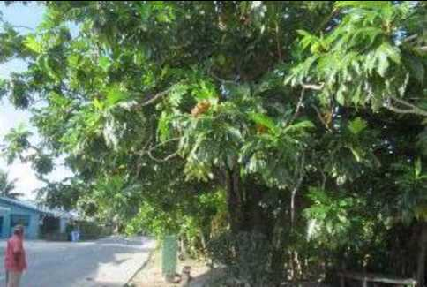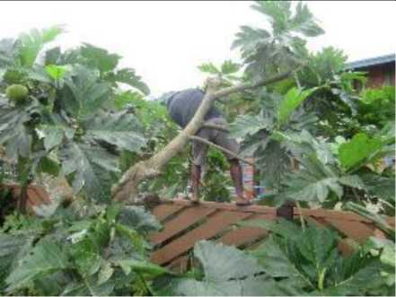

Productive breadfruit trees lining the streets or urban Funafuti

A breadfruit being pruned by its owner on Funafuti to increase its productivity and sell suspectable to cyclone damage

Breadfruit can be cooked and eaten at all stages of maturity, is high in carbohydrates and also a good source of minerals and vitamins. It is often the primary component of traditional agroforestry systems. In Tahiti, breadfruit flour is available and manufactured in a small 100% artisanal operation (Taylor et.al 2016 p, 174). In Fiji, the Tutu Rural Training Centre on Taveuni commenced manufacturing breadfruit flour in 2017 (McGregor and Stice 2018)**[13]**. In Tuvalu and Kiribati breadfruit chips are regularly made by households for their home consumption. Opportunities have been identified to expand this into a small cottage industry scale business.

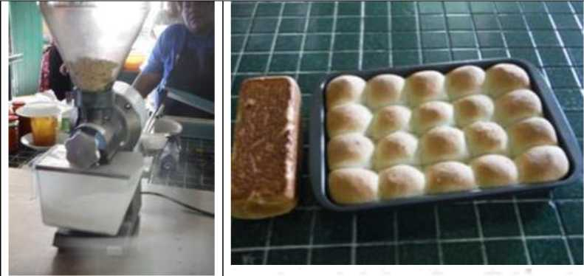*A small grinder for manufacturing breadfruit flour at the Tutu Rural*

*Training Center, Taveuni Fiji*

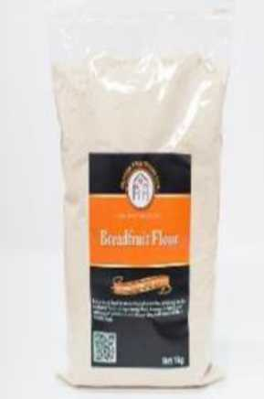Breadfruit (mei), along with coconuts, are the main traditional staple of Tuvaluan households. The same prevails for Kiribati. The fruit are available for around eight months a year, but not between October and November (just prior to the cyclone season) or April and May (usually just after the cyclone season). As with coconuts this crop survives, rather than thrives, in the harsh atoll conditions and compost and better soil is usually added to a seedling to give it a better start. There are fewer breadfruit varieties in Tuvalu than in volcanic islands, but there are several Tuvaluan varieties of both species of breadfruit, *Artocarpus aItilis and Artocarpus mariannensis (*Ragone 1988*).* There are also popular varieties that were relatively recently introduced from Samoa (aveloa and ma'afala). The older Tuvaluan or Kiribati cultivars that evolved in atoll conditions are thus well adapted to them. *A. mariannensis* cultivars and hybrids are particularly well adapted as this species is endemic to the North and Central Pacific, where most islands are atolls.

Buns and bead made from 30% breadfruit flour at the Tutu Rural Training Centre

Breadfruit flour manufactured in Samoa for sale in New Zealand

While breadfruit is tolerant of poor soils, it cannot sustain salt spray, and this restricts the areas where they can be grown. If breadfruit trees are well pruned, they are highly tolerant to severe cyclones - although most of the fruit will be lost. This was demonstrated by the Pacific Breadfruit Project’s orchards in Fiji with severe TC Winston - where only 2% of the three-year-old breadfruit orchard trees were destroyed by the category 5 cyclone (Erasito 2018). This tolerance was also demonstrated in Samoa following Category 4 Cyclone Ofa that struck in February 1990. Clark (1992)**[14]** describes the impact:

Observations three months after the cyclone were that trees still standing and even many blown over had refoliated. Many trees in villages had dead or damaged limbs pruned off and had a new flush of leaves up to the trunk and remaining branches. Shoots coming from the roots of fallen trees took a few months to come up to a size ready to replant. There was an abundance of these to replace fallen trees. Most trees flowered later and were bearing a heavy crop of immature fruit by October (p. 71).

Pruning the breadfruit trees should be an essential component of maintenance because it increases the efficiency of harvesting, improves fruiting because the fruit is borne on new growth, removes any weak or damaged branches that could break and damage fruit, and finally a well-pruned tree will suffer less in high winds and therefore recovers quicker after any storm damage. A relativelynew dwarf variety has come become popular following TC Pam and planting material is now being shared.

Breadfruit requires relatively high levels of rainfall but can survive droughts of 3-4 months after the tree is established (Elevitch and Wilkinson 2000)**[15]**. Prolonged droughts have destroyed trees in the Micronesian atolls, and caused damage to trees in Guam, Pohnpei, Samoa, the Marquesas and other high islands (Ragone 1997).

Breadfruit trees can be quite tolerant to salinity, but with ageing trees, saltwater incursions further weaken the trees increasing their susceptibility to disease (Taylor et. al 2016 p. 204) Salt intrusion has been reported as a contributing factor to the ‘trunkrot’ disease experienced in Kiribati**[16]**. The problem occurs especially in seeded breadfruit and rarely in seedless varieties. Hence, increasing sea-level events, such as storm surges, are likely to weaken old trees, making them more susceptible to disease.

On low-lying atolls repeatedly inundated by storm and ENSO-generated tides, breadfruit trees are often uprooted and destroyed. The majority of breadfruit cultivars are highly susceptible to even short periods of sea-water inundation and have been observed to be killed by a single king tide event in Kiribati although there is genotype variation in tolerance to salinity (Taylor et.al. 2016 Chapter 4)**[17]**. Many of the Pacific atoll states and low-lying coastal areas breadfruit grows in a relatively saline environment in terms of both groundwater and salt spray. Overall coconuts are regarded much more resistant to sea-water inundation on such short timescales as king tide events or tsunamis.

Taylor et.al. 2016 concluded that: “Increasing temperatures are unlikely to have much impact on breadfruit at least to a 2°C increase, although fruit drop and smaller fruit are likely to be a problem if heat stress is accompanied by low rainfall” (p, 196).

* + 1. Pulaka (swamp taro)

The aroid tuber known as pulaka (*Cyrtosperma chamissonis*) is an important traditional crop in Kiribati and Tuvalu. In other Pacific island countries, it is a relatively unimportant tuber, mainly used as an emergency crop or as animal feed. Pulaka cannot tolerate sandy porous soil and therefore is planted in pits where the ground is damp and muddy, below the lens of percolated rainwater. Pulaka cultivation is very labour intensive (digging the planting holes and continually maintaining compost). It takes around five years to produce a reasonably sized tuber from a top. A particularly large and prestigious pulaka produced from a top can take up to ten years of continuous attention. However, small tubers suitable for household consumption can be produced in about a year. Swamp taro is important in atoll locations, due to its tolerance of swampy conditions and some degree of salinity (although this appears to be very genotype-dependent). Tuvalu and Kiribati’s isolation has meant that the crop has few pest problems. The crop is resistant to strong wind even when it is full-grown, enabling it to survive cyclones with a minimum of wind damage.

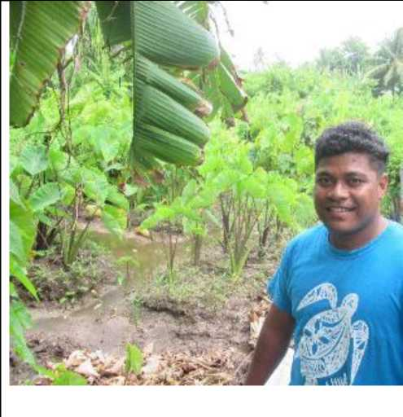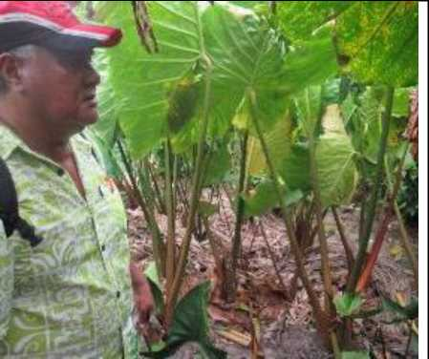

Two of the three remaining Pulaka pits on Funafuti. On

the left the pit is worked on behalf of his family by Selotia Tausi Department of Agriculture Quarantine Officer. A briefing on the pulaka pit on the right is being provided Itaia Lausaveva the former Director of Agriculture

Aroids generally have a low tolerance to salinity. The FSM damage assessment report carried out in response to the tidal surges of December 2008, showed that the majority of swamp taro patches in the outer islands were affected and as a result, many communities said they would cease cultivating taro (Susumu et al. 2009)**[18]**. However, a study carried out by Rao (2010) in Tuvalu, indicated that some varieties of swamp taro are reasonably tolerant to salinity. Preliminary research carried out by the Secretariat of the Pacific Community Centre for Pacific Crops and Trees (SPC CePaCT) on the salinity tolerance of different varieties of swamp taro from Kiribati indicates some genotype influence. However, as pointed out by Webb (2007)**[19]**, the response of swamp taro to salinity is very complex.

Pulaka does not tolerate droughts. In 2011, Tuvalu declared a national emergency when a period of no rain led to a water shortage. The vulnerability of the pulaka to dry conditions was particularly highlighted and salinity problems were exacerbated illustrating the effect of multiple climate-related stresses (SPC 2011). Fortunately, the 2011 drought ended with an extended period of heavy rain that flushed much of the salt water from the pits. It continues to be important for food security and has significant cultural value, but its value as a staple food crop is declining. An assessment of the salinity of the ground water in pulaka pits undertaken by SOPAC in 2007 concluded that with exception of one pit sampled, all other pits sampled “had average ground water salinity conditions that were acceptable and low enough, to allow successful swamp taro cultivation (Webb 2007 p, 34). However, increasing salinization could result in swamp taro production declining in importance in the short term (2030) and possibly disappearing entirely in the medium term (2050) (Taylor et.al 2016).

* + 1. Taro (colocasia)

*Colocasia* taro is usually also grown on the edge of the pulaka pits. However, these tend to be dry land varieties not “water taro” varieties commonly grown in Hawaii, Vanuatu and the Cook Islands. Hence considerable effort is required in composting mulching and mounding to protect them from saline water. Taro faces the additional disadvantage of not being as tolerant to strong winds.

However, taro offers a particular advantage of being harvestable within a year if it is well looked after.

*Xanthosoma* taro (coco yam) regarded generally as being one of the most climate resilient of root crops grown in the Pacific islands, is not grown in Tuvalu.

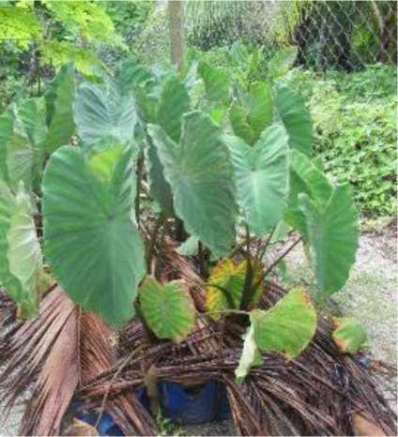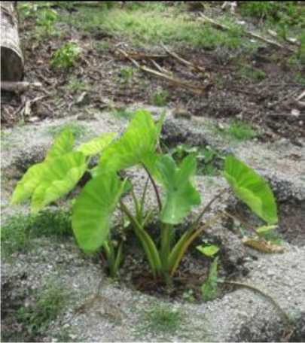

Attempts to grow Colocasia taro outside paluka pits on Funafala island Funafuti atoll

* + 1. Kumala

Kumala (*Ipomoea batatas*) and cassava is the only root crop that is not grown in pulaka pits. While kumala is relatively drought tolerant It can only be realistically be grown on atolls that have sufficient rainfall such as on Tuvalu’s southern islands. The major advantage kumala offered was its ability to be grown on sandy soil at the apron of the beach. Thus, it became a priority crop for the

Tuvalu Dept. Ag. in the 1980s (Crop Development Handbook for Agricultural Workers in Tuvalu). This program was so successful that an attempt was made to export kumala to the Marshall Islands. While kumala is quite tolerant to wind damage, being planted at the edge of the beach makes it susceptible to storm surge. Most is therefore destroyed in a cyclone. To quote the Tuvalu National Disaster Committee (NDC) damage assessment for cyclones Joni, Kina, and Nina on Vaitupu:

It is generally regarded that food tree crops near the shoreline and those growing in low elevation areas with will totally collapse due to flooding of the area with sea-water. An area of 1,000 square meters of sweet potato was completely buried in sand from the beach (McGregor and McGregor 1999 p, 74)

For this reason, unfortunately, kumala has largely been abandoned as a food crop for low lying atolls.

* + 1. Cassava

Cassava, along with *Xanthosoma* taro, is regarded overall as the most climate resilient of the tuber crops. Cassava is considered highly tolerant of drought, and can be grown where precipitation is 500 mm/year (FAO 2010) (See Chpt 4 Taylor et.al 2016). However, cassava is particularly susceptible to waterlogging and to high winds (>30 knots) which can cause lodging of the plants. Lodging results in severe root damage which is rapidly translated into root rots and loss of the whole plant. Farmers anticipating the arrival of a cyclone can cut off the stems above ground level, reducing the damage to the roots. Moreover, the crop can be planted at any time of the year and some varieties can be stored in the ground for two to three years, providing some insurance against more intense cyclones.

The intolerance of cassava to water logging means that there are limited areas on atoll where the crop can be grown. These areas are usually found in close proximity to houses. Planting holes need to be dug with some soil compost and mulch added and ideally spread around each plant a small quantity of NPK fertiliser - which contains trace elements such as iron. Small quantities of cassava now being successfully grown in both Tuvalu and Kiribati

* 1. Assorted traditional crops (pandanus, banana laulu etc.)

Pandanus (*Pandanus tectorius*) or fala grows both wild and cultivated, and is used as raw material for handicrafts as well as a food source. Many things were once made with dried pandanus leaves, but less so today, other than mats, fans, tourist trinkets, and rolling material for tobacco. The leaves are also an important component of the pit compost system. The fruit was a more important food source in the past, but is still consumed today, in both raw and cooked states. Even in urban Majuro, more than 40% of households grow some pandanus (FAO 2010). The multipurpose *P. tectorius* (beach pandanus) is extremely well adapted to diverse climates and adapted to future climate change including warmer temperatures, drought, saltwater incursion and fire. The species is highly drought- and salt-tolerant and well adapted to atoll environments being far more drought tolerant than coconuts on atolls (Taylor et.al 2016). Pandanus as with the majority of near-coastal/strandline tree and shrub species, have a degree of tolerance to both sea-salt spray and salinity in the root zone, but salt tolerance varies depending on species and the type of salt stress. Most tree and shrub species growing close to the seashore are likely to be classified as salt tolerant non-halophyteswhose tolerance mechanisms involve restricting the movement of salt into the shoot system (Thomson and Thaman 2016)**[20] [21]**

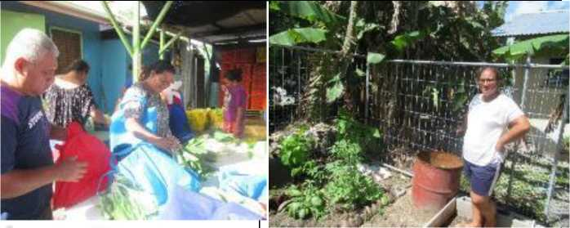During low to moderate intensity cyclones (Category 1-3), Calvert (2011)22, reported that beach pandanus was either mostly undamaged or merely suffered broken branches. Thus, they are a vital component of an agroforestry cropping system on atolls. For the most exposed and at-risk coastal sites, plantings should be focused on fast-growing, easily established species, such as *Hibiscus tiliaceus* and *Pandanus tectorius* through branch cuttings (Thomson and Thaman 2016)

* + 1. Introduced fruit and vegetables

The Crop Development Manual for Agricultural Workers in Tuvalu presents a package of practices for a wide range of fruit and vegetable crops. This include: beans, cabbage (Chinese and English) corn, cucumber, eggplant, onions, sweet peppers, hot peppers, pumpkins, radish, rockmelons, tomatoes, watermelons, papaya and pineapple. The Taiwan Technical Mission, which has been in operation in Tuvalu and Kiribati since 2003, has promoted these crops in its nurseries through the development of appropriate composting systems. The most successful of introduced fruit and vegetable crops have been: cabbage, cucumber, egg plant, onions, sweet and hot peppers, pumpkin and tomatoes. The TTM operate regular market days where they sell their products to the public and offer space for growers to sell - although few seldom do. TTM provides regular training programs to interested growers and provide seedlings and some other inputs. In Tuvalu the update to the main uptake has been with a few home gardens who grow for their households with any surplus going to their extended families. In Kiribati a few small commercial vegetable growers are reported to have emerged to greater availability of land on Tarawa. However, considerable scope is identified for expanding fruit and vegetable growing on Funafuti, and some nearby islands, based on home gardens - which would have significant health and nutrition benefits

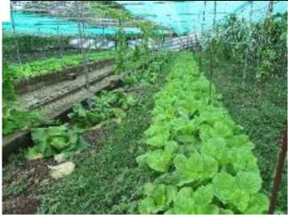*Buyers at the TTM Saturday morning vegetable market*

Cabbages and other vegetables grown at the TTM Funafuti Garden

*Puaolele Elisala with her Funafuti home vegetable garden*

* + 1. Processing and food preservation

The focus of food preservation in Tuvalu and Kiribati is the drying of food. Techniques common in volcanic islands, such as smoking and fermenting, are not usually used these atoll countries probably because the drier climate favours drying, but also because fermentation in Pacific island societies is usually done in deep pits, which is not possible in Tuvalu and Kiribati because of the high, brackish water table. A small amount of fermentation is nevertheless practiced, mainly by older women who went to school in Samoa. There are drying methods for almost every traditional food in Tuvalu. All manner of fish is cooked in the umu (earth oven) until hard and then sun dried, enabling them to keep for up to one year. When needed, fish are soaked overnight and cooked in coconut cream.

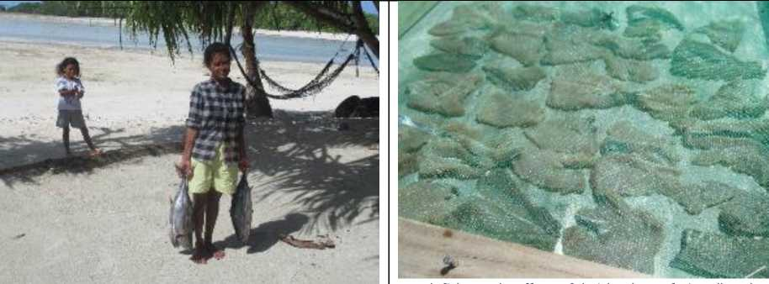

Fresh fish caught off Funafala island Funafuti atoll soaked overnight in sea water and dried directly in the sun

however, these methods are more common. Preserved foods are often sent by outer islanders to their relatives on Funafuti in exchange for the imported goods that people on Funafuti have access to. Given the irregularity of the shipping services, these are popular as trade items, as they will not go bad waiting for the ship to turn up. These are also popular foods to send to Tuvaluans for the same reason. Even so, the popularity of these foods has declined even on the outer islands.

Imported foods have gained a foothold at the expense of all traditional foods, particularly those that take work to prepare. The preservation methods survive today primarily for the reasons named above.

* 1. Demographic trends

As of the last population census (2012) Tuvalu had a population of 10,782 of which 6,152 lived n Funafuti 4,630 on the outer-islands. Males made up 51% of the population and females 49%. It is a particularly young population 33% of the population being below the age of 15 and only 9% over the age of 60. For the outer-islands 32% were below the age of 15 and 10% above the age of 60.

Over the period 2002 - 2012 the national population growth was 1.2% with the Funafuti population growing by 3.1% and the outer island population declining -0.9%. This resulting in a population density 1,918 persons/sq km on Funafuti and only 228 persons/sq km in outer islands.

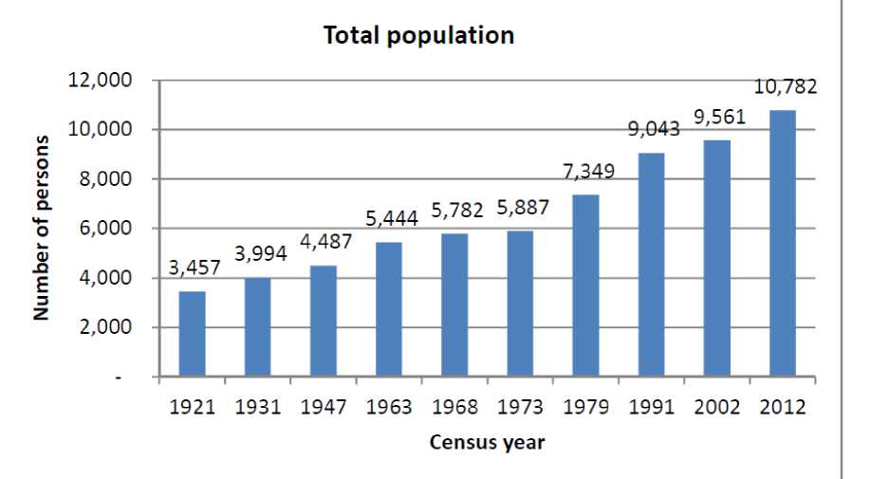

***1: Tuvalu***

***ion from 1921 to 2012***

he 2012 Population Census indicated a national unemployment rate of 40.7 % for males 15 years

and older and 38.1% for females. In the outer-islands the rates were 48.8% and 41.7% respectively.

Kiribati, according to the 2015 Population Census, had a total population of 110,158 (up from 103,058 in the 2010 Census - 1.4% annual growth rate. Over the same period the population of South Tarawa increased from 50,182 to 56,388 at 6.2% annual increase. Kiribati has a particularly young population with 37% of the total population being 15 years or below and 66% of the population being below the age of 61 (table 3).

*Table 3: The age distribution of the Kiribati population\**

|  |  |  |  |  |
| --- | --- | --- | --- | --- |
| **Age Category** | **Total Males** | **Total Females** | **Total** | **% of Total Population** |
| 0-15 Years | 21,049 | 19,888 | 40,937 | 37% |
| 16-30 Years | 16,344 | 15,742 | 32,086 | 29% |
| 31-60 years | 15,417 | 16,392 | 31,809 | 29% |
| 61 years and Above | 2,350 | 3,859 | 6,209 | 6% |
| Total Population | 55,160 | 55,881 | 111,041 |  |

*Source: 2016 HIES

* 1. Food preference and the incidence of NCDs

Pacific island countries have undergone a ‘nutrition’ transition from diets largely based on locally grown food to those primarily based on processed, imported, foods. This is more so for the atoll countries as reflected in the import data for Tuvalu and Kiribati presented below.

Tuvalu Food Imports Value ($AUD '000) and Volume (tons) 2010-2016

|  |  |  |  |  |  |  |  |  |
| --- | --- | --- | --- | --- | --- | --- | --- | --- |
| **Product** | **2010** | **2011** | **2012** | **2013** | **2014** | **2015** | **2016** | **Average** |
| Edible | 420 (t) | 402 (t) | 377 (t) | 388 (t) | 450 (t) | 494 (t) | 503 (t) | **433 (t)** |
| Meat | 638 ($) | 865($) | 846 ($) | 648 ($) | 661 ($) | 439 ($) | 472 ($) | **653($)** |
| Fresh | 66 (t) | 2 (t) | 8 (t) | 1 (t) | 1 (t) | 6 (t) | 1 (t) | **12 (t)** |
| Seafood | 49 ($) | 16 ($) | 31 ($) | 12 ($) | 9 ($) | 8 ($) | 3 ($) | **18 ($)** |
| Dairy | 222 (t) | 142 (t) | 84 (t) | 79 (t) | 54 (t) | 50 (t) | 69 (t) | **100 (t)** |
| Products | 115($) | 466($) | 369 ($) | 300 ($) | 269($) | 153($) | 167($) | **263($)** |
| Vegetabl | 174 (t) | 296 (t) | 202 (t) | 141 (t) | 173 (t) | 134 (t) | 211 (t) | **190 (t)** |
| es | 125($) | 203($) | 166($) | 134($) | 132($) | 96 ($) | 169($) | **146 ($)** |
| Fresh | 33 (t) | 83 (t) | 67 (t) | 42 (t) | 42 (t) | 43 (t) | 48 (t) | **51 (t)** |
| Fruit | 50 ($) | 92 ($) | 83 ($) | 53 ($) | 51 ($) | 38 ($) | 71 ($) | **63 ($)** |
|  | 96 (t) | 268 (t) | 380 (t) | 356(t) | 371 (t) | 340 (t) | 283 (t) | **299 (t)** |
| Rice | 121($) | 402($) | 442 ($) | 361 ($) | 319 ($) | 204($) | 366 ($) | **316 ($)** |
| Edible | 1,103 (t) | 580 (t) | 64 (t) | 102 (t) | 1,036 (t) | 62 (t) | 57 (t) | **429 (t)** |
| Oils | 783 ($) | 736($) | 149($) | 1,189 ($) | 1,413 ($) | 987 ($) | 522 ($) | **825 ($)** |
| Sugar &  Confectio | 359 (t) | 548 (t) | 576 (t) | 499 (t) | 583 (t) | 619 (t) | 489 (t) | **525 (t)** |
| nary  Products | 299($) | 604($) | 547 ($) | 452 ($) | 497 ($) | 356 ($) | 407($) | **452 ($)** |
| Wheat | 792 (t) | 450 (t) | 503 (t) | 660 (t) | 940 (t) | 984 (t) | 559 (t) | **698 (t)** |
| Products | 858 ($) | 868($) | 872 ($) | 1,189 ($) | 1413 ($) | 987 ($) | 522 ($) | **958 ($)** |
| Beverage s and | 610 (t) | 674(t) | 328(t) | 485 (t) | 222 (t) | 195(t) | 319 (t) | **405 (t)** |
| Spirits | 351 ($) | 686($) | 514 ($) | 455 ($) | 590 ($) | 412 ($) | 519 ($) | **503 ($)** |
| **Total Food Imports (‘000)** | **3,389** | **4,938** | **4,019** | **4,793** | **5,354** | **3,680** | **3,128** | **4,186** |
| **Total Imports (‘000 $)** | **24,305** | **26,350** | **20,229** | **21,430** | **24,561** | **49,037** | **31,596** | **28,215** |
| **% of Total** | **14%** | **19%** | **20%** | **22%** | **22%** | **8%** | **10%** | **16%** |

Source: SPC Prism Statistics Division

**Kiribati Food Imports Value ($AUD '000) and Volume (tons) 2018\***

|  |  |
| --- | --- |
| **Product** | **2018** |
| Edible Meat | 2,151 (t)  8,888 ($) |
| Fresh  Seafood | 660 (t)  1,585 ($) |
| Dairy  Products | 491 (t)  2,743 ($) |
| Vegetables | 276 (t)  889 ($) |
| Fresh Fruit | 79 (t)  220 ($) |
| Rice | 34,972 (t)  11,064 ($) |
| Edible Oils | N/A |
| Sugar & Confectionary Products | 4,669 (t)  4,607 ($) |
| Wheat  Products | 15,695 (t)  6,626 ($) |
| Beverages and Spirits | N/A |
| **Total Food Imports** | 45,529 ($) |
| **Total Imports** | 137,387 ($) |
| **% of Total** | 33% |

**\*Source: SPC Prism Statistics Division**

The summary table 4 below prepared recently by the NGO Live and Learn provides a broad indication of how food consumption patterns have changed in recent decades. The diets based on these imported foods are generally considered as nutritionally-inferior to traditionally produced food and have been identified as a major contributor to two types of malnutrition (under-nutrition and over-nutrition) that are prevalent throughout the region (Taylor 2017, FAO 2014)**[22]**. The prevalence of overweight adults in the PICs is among the highest in the world. Adult obesity rates are at or above 60 per cent, in Tonga and the Cook Islands and above 45 per cent in Kiribati, Republic of the Marshall Islands and Tuvalu (figure 3). Non-communicable diseases (NCDs) are now the leading cause of death in most countries in the Pacific. For the atoll countries they range from 67% for FSM to 73% for Tuvalu figure 4(Xu et.al)**[23]**. Diabetes is particularly prevalent in the Pacific

islands and has increased steadily over the last four (4) decades. The PICs now rank the highest in the world in terms of the prevalence of diabetes - with 7 PICs (including 4 atoll countries are) are ranked in the top 10 countries in the world in terms of diabetes prevalence (table ).

|  |  |
| --- | --- |
| ***Table 4: Main foods consumed in the past compared to main foods consumed today****\**  Tuvalu (Funafuti and Outer Islands)  Main foods consumed today Main foods consumed in the past  **Mainly:** Pulaka (baked, grated, or  Rice preserved)  Biscuits Taro (root crop)  Bread Pandanus  Imported Chicken Breadfruit  Homegrown chicken Coconut  Canned tuna Uto (sweet chewable fibre  Other imported canned found in pandanus and  foods coconut, eaten fresh or  Breadfruit roasted to preserve it)  Pulaka (root crop) Bananas  Imported taro (from Fiji) Laulu (local green fern)  Laulu (local green fern) Fig  Germinating nuts (stored to preserve them) Some: Felo (small apple-like  Pumkin fruit)  Cassava (import from Fiji Locally raised chicken  and Vietnam) Locally raised pork  Pandanus Locally caught fish (fresh  Cabbage dried/salted for  Taiwanese Pawpaw preservation)  Taiwanese Cucumber Clams  Fresh caught fish Crabs  Crabs Seashells  Clam Turtles  Pork Seabirds  Main drinks: Water, soda in Main drinks: Toddy (sweet cans and cordial sap found in coconut  palms), and coconut water | *The Tuvalu Director of Agriculture, Uatea, enjoys a traditional lunch of raw fish in coconut cream* |

|  |  |
| --- | --- |
| Tuvalu (Funafuti and Outer Islands) | |
| Main foods consumed today | Main foods consumed in the past |
| **Mainly:**  Rice  Biscuits  Bread  Imported Chicken Homegrown chicken Canned tuna  Other imported canned foods Breadfruit  Pulaka (root crop) Imported taro (from Fiji) Laulu (local green fern)  Some:  Pumkin  Cassava (import from Fiji and Vietnam) Pandanus  Cabbage  Taiwanese Pawpaw Taiwanese Cucumber Fresh caught fish Crabs Clam Pork  Main drinks: Water, soda in cans and cordial | Pulaka (baked, grated, or preserved)  Taro (root crop) Pandanus Breadfruit Coconut  Uto (sweet chewable fibre found in pandanus and coconut, eaten fresh or roasted to preserve it) Bananas  Laulu (local green fern)  Fig  Germinating nuts (stored to preserve them) Felo (small apple-like fruit)  Locally raised chicken Locally raised pork Locally caught fish (fresh dried/salted for preservation)  Clams  Crabs  Seashells  Turtles  Seabirds  Main drinks: Toddy (sweet sap found in coconut palms), and coconut water |

*Source: Live and Learn. A Rapid Assessment of the Perception in Food Security in Tuvalu. Tuvalu July 2019

**Figure 3 : Estimated percentage of total deaths caused by NCDs in PICs\***

90%

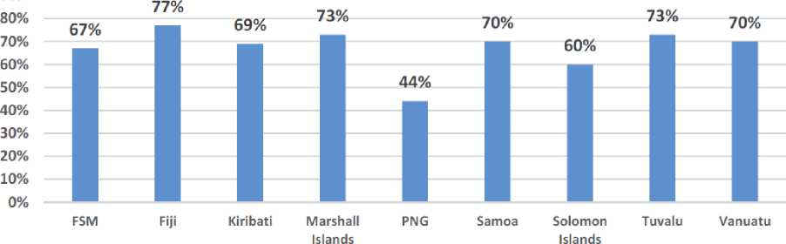

*Xiaohui Hou, Ian Anderson, Ethan-John Burton-Mckenzie (2016). Pacific Possible: Health & Non­Communicable Diseases. Background Paper. World Bank, July 2016.

Table 5: Top ten countries/territories for diabetes prevalence in the world*

|  |  |
| --- | --- |
| **Counl iy iTmiiory** | **201) Prevalence (X) of dubeirt 120 79 yean)** |
| **Ttrkriau**  **Federated Staten *vt* Murzin**  **Republic c4 [he Marthall liUndt**  **Kiribati**  **Cook hlandr**  **Vanuatu**  **Saudi Arabia**  **Niuru**  **Kuwait**  **Qatar** | **37.5**  **350**  **34.9**  **28J**  **25.7**  **2J.0**  **24.0**  **213**  **23.1**  **32.9** |

*International Diabetes Federation (2013) Global estimates of diabetes prevalence for 2013 and projections for 2035

In 2011, Pacific leaders declared the NCD epidemic a health and economic crisis and a threat to sustainable human development (WHO/SPC, 2011)**[24]**. A report released at the Pacific NCDs Summit in Nuku’alofa, Tonga (June, 2016) further highlighted the economic threat posed by NCDs in the Pacific Islands. In particular, there are major public health costs incurred. The share of public health expenditure is growing for most countries in the Pacific, raising questions about long-term financial sustainability (World Bank 2016)**[25]**. This includes the ability of the populations of these countries to be able to adapt and adjust to climate extremes and climate change.

Many social and economic factors have contributed to the increase in diabetes. However, the overall far greater consumption of westernized foods and neglect for the traditional diet by Pacific Island communities has undoubtedly played the pivotal role (Chan et al., 2014**[26]**; Ragone & Raynor, 2009**[27]**; WHO, 2010**[28]**; World Bank 2016). A combination of behaviour factors (tobacco smoking, lowphysical activity, and poor diet) are the major contributors to diabetes. Of these factors, diet is seen as the dominant contributor as indicated by research conducted by the Institute for Health Metrics and Evaluation, (IHME) (World Bank 2016)**29 [29]**. This research identified poor diet (base on imported food) to be the dominant risk factor in the death from diabetes in Kiribati, Marshall Islands and FSM (figure 5)

**Figure 5: Diabetes mortality rates attributed to risk factors\***

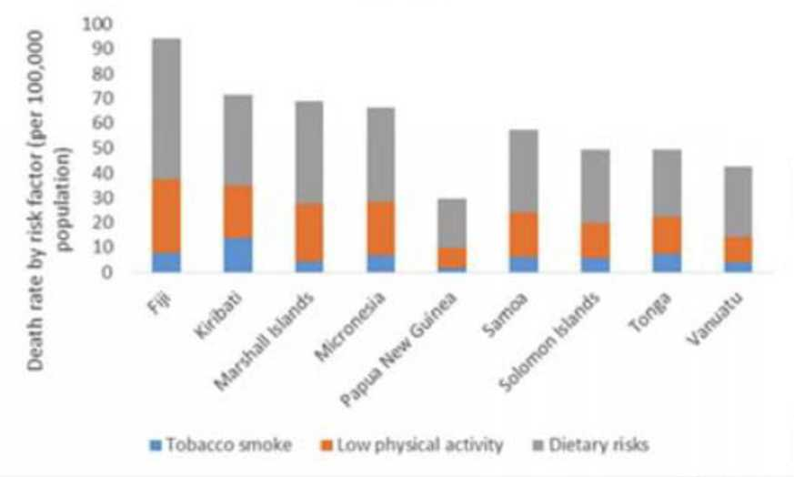

Source: World Bank 2016 p, 3.

The recent Household Income and Expenditure Study (HIES) for Tuvalu 2015/16 provides some quantification of the obesity problem for atoll countries, to quote (p, 57):

Nationally, 49 percent of the population aged 15 years and over reported a height and weight that computes to a BMI lower than 30 (normal or overweight). The obese population (BMI between 30 and 40) represents 41 percent of the population and the severe obesity (BMI higher than 40) affects 10 percent of the same adult population. By gender obesity is more common in the female population: 42 percent are obese and 13 percent severe oberese and respectively 39 and 8 percent for the males.

By strata, the results differ as the proportion of obese and severe obese is higher in rural Tuvalu (Figure 7)

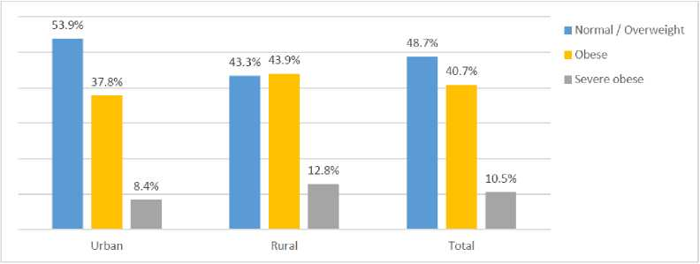

Figure 7: Distribution of the population aged 15+, by BMI category and strata

By age group, obesity is more important between 25 and 64 years old. Within those age groups on average more than 60 percent of the population is obese with a peak between 45 and 49 years old (76 percent of obesity included 18 percent of severe obesity).

Turi et al. (2015)**[30]** refer to a number of studies that indicate that diets based on traditional Pacific staples such as breadfruit can mitigate the prevalence of type II diabetes. This conclusion is based on a combination of field observations, ethno botanical reports and medical records. The nutritional advantages offered by breadfruit and breadfruit products are summarised below.

Breadfruit and traditional root crop staples are high in complex carbohydrates, rich in fiber, low in fat, and cholesterol and gluten free. Breadfruit for example has a moderate glycemic index (blood sugar shock) compared to that of white potato, white rice and white bread (table 5).

**Table 5: A “typical” nutritional comparison of breadfruit with potato and white rice (per 100 g serving)\***

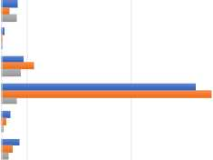

|  | Breadfruit | White  potato | White rice |
| --- | --- | --- | --- |
| Protein (g) | 4 | 1.7 | 2.4 |
| Carbohydrate (g) | 31.9 | 15.7 | 28.6 |
| Fiber (g) | 5.4 | 2.4 | 0.3 |
| Phosphorus (mg) | 43.1 | 62 | 37 |
| Potassium (mg) | 376.7 | 407 | 29 |
| Calcium (mg) | 16.8 | 9 | 3 |
| Magnesium (mg) | 34.3 | 21 | 13 |
| Sodium (mg) | 19.4 | 16 | 0 |
| Iron (mg) | 0.5 | 0.5 | 0.2 |
| Zinc (mg) | 0.1 | 0.29 | 0.42 |
| Vitamin C (mg) | 2.4 | 9.1 | 0 |
| Thiamin (mg) | 0.1 | 0.07 | 0.02 |
| Riboflavin (mg) | 0 | 0.03 | 0.016 |
| Niacin (mg) | 0.9 | 1.06 | 0.4 |
| Vitamin A (pg) | 1.4 | 0 | 0 |
| Lutein (pg) | 96.3 | 0 | 0 |
| b-Carotene (pg) | 15.1 | 0 | 0 |

Protein (g)

Carbohydrate (g)

Fiber (g)

Phosphorus (mg)

Potassium (mg)

Calcium (mg)

Magnesium (mg)

Sodium (mg)

Iron (mg)

Zinc (mg)

Vitamin C (mg)

Thiamin (mg)

Riboflavin (mg)

Niacin (mg)

Vitamin A (pg)

Lutein (pg) b-Carotene (pg)

■ Breadfruit ■ White potato ■ White rice

*Source: Elevitch, Ragone and Cole, Breadfruit Production Guide: Recommended Practices for Growing and Harvesting 2nd Edition 2014

The three (3) key positive nutritional features of breadfruit and traditional food staples that that can contribute to an overall reduction in NCDs are (see McGregor and Stice 2017):

1. being gluten free and low in FODMAP elements;
2. having a moderate glycemic index; and,
3. a high non-digestible carbohydrate context (high amylose content).

In the fight against NCDs, obesity and in particular diabetes, there is increased interest in processed food products that combine a low GI and high fibre content (Lafiandra et. al, 2014)**32**. Breadfruit flour and paste is such a food. Breadfruit is also seen as a useful source of vitamin C, potassium, magnesium, and calcium, with small amounts of thiamine, riboflavin, niacin and iron. Opportunities have been identified for small scale commercial processing of breadfruit into products such as flour and chips that result in import substitution (McGregor and Stice 2018)

3.5 Kiribati

* + 1. Current situation

Kiribati’s food imports for 2018 are presented in table 6 below. Food imports accounted for 33% of total imports. The largest imports were rice and wheat products, which together made up 38% of food products imported into Kiribati last year. Kiribati could be expected to be similar to Tuvalu in

32 Lafiandra, D., Riccardi, G., & Shewry, P. R. (2014). Improving cereal grain carbohydrates for diet and health. Journal of Cereal Science, 90, 312e326.

terms of having the potential to substitute these imports with breadfruit and taro. Although there is no specific figure for imported edible oils mentioned for Kiribati in the latest available data, it is most likely comparable in significance to Tuvalu, with locally produced coconut or high - quality copra oil having potential as a substitute product.

*Table 6: Kiribati Food Imports 2018 - value ($AUD'000), volume (tonnes)\**

|  |  |
| --- | --- |
| Krooni CT | ZU1B |
| Edible Meat | 2,151 (t)  S.88S ($) |
| Fresh  Seafood | 660 **(t)**  X5B5[$) |
| Dairy Products | 491 **(t)**  2,743 ($} |
| Vegetables | 276 **(t)**  389 **($J** |
| Fresh Fruit | 79 (t)  220 ($) |
| Rice | 34,972 **(t}**  11,064 ($) |
| Edible Oils | N/A |
| Sugar & Confectionary Products | 4,669 (t)  4,607 ($} |
| Wheat  Products | 15,695 **|t}**  6,626 ($) |
| Beverages and Spirits | N/A |
| Total Food  Imports ('000$ | | 45,529 ($) |
| Total Imports ('000$} | 137,387 ($) |
| % of Total | 33% |

Source: SPC Prism Statistics Division

The last HIES Survey for Kiribati was conducted in 2006. This found the total annual household income to be over 122 million dollars. It is presented in the table 7 below:

Table 7: Total annual household income by source for Urban/Rural

|  |  |  |  |
| --- | --- | --- | --- |
| **Source of Income** | **S Tarawa |** | **Outer Islands** | **Total** |
| Wages & Salaries | $28,421,000 | $14,902,000 | $43,322,000 |
| Self Employment | $263,000 | $530,000 | $793,000 |
| Agric & Fish Sales | $2,502,000 | $10,871,000 | 313,373.000 |
| Home Produce Sales | $1,242,000 | $5,393,000 | $6,635,000 |
| Remittance & Gifts | $6,068,000 | $5,645,000 | $11,713,000 |
| Casual Jobs | $32,000 | $138,000 | $170,000 |
| Welfare Allowances | $111,000 | $211,000 | $322,000 |
| 1” Pensions | $298,000 | $258,000 | $556,000 |
| Subsistence Activity | $8,782,000 | $17,542,000 | $26,323,000 |
| Imputed Rent | $11,336,000 | $5,710,000 | $17,047,000 |
| Other Income | $1,073,000 | $1,097,000 | $2,169,000 |
| **Grand Total** | $60,128,000 | $62,296,000 | $122,423,000 |
|  | | | |

Wages and salaries are the most important income source for urban areas at $28 million or 47% of the total income. In rural areas however, wages and salaries account for 24% of total income.

Subsistence is the main income generating activity in rural areas of Kiribati - accounting for 28% or $17.5 million of total income. Wages and Salaries represent 35% of national income while subsistence activities accounted for 22%. Other significant sources of national income include: imputed rents (14%), sale of agricultural products and fish (11%), remittances and gifts (10%) and sale of home produce (5%). These statistics are illustrated in fig 3.1 below taken from 2006 HIES:

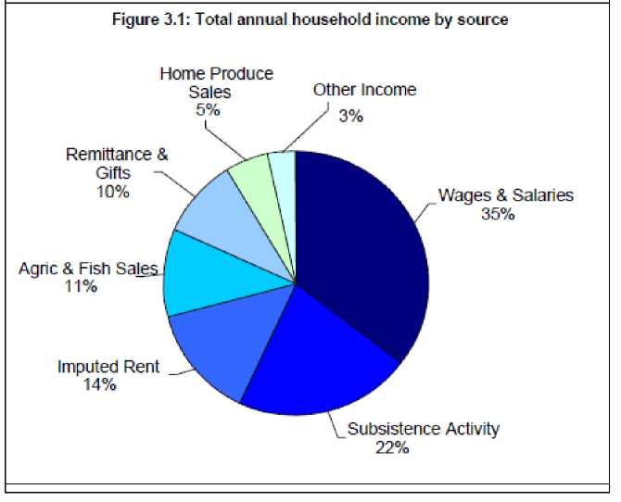

The average household income for Kiribati was around $8,700 dollars, with households in the Lines and Phoenix group having the highest average income of $12,300, followed by South Tarawa with $11,500. The southern group was in the lowest annual income bracket with around $5,000.

Kiribati’s per capita income stood at $1,400 (see figure 3.2). People living in the Line and Phoenix group were found to have the highest per capita income, exceeding $1,900 per person per year. The southern group had the lowest per capita income at just over $1,000.

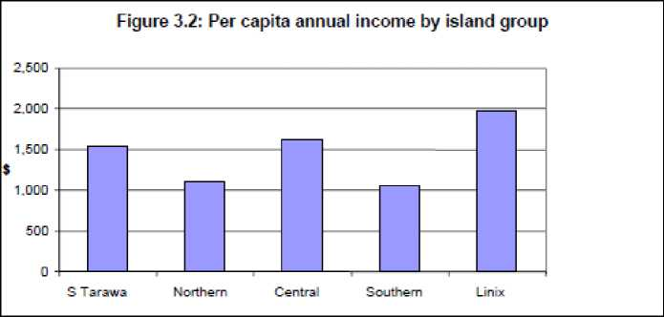

Kiribati National Statistics Office 15

Kiribati’s total annual household expenditure in the last survey was $132 million. Urban area households spent 69 million dollars, with rural household expenditure totaling $63 million dollars. Expenditure exceeded incomes by almost 10 million dollars. Expenditure on food was the highest making up 46% of total income expenditure. Other major areas including housing, transport and travel, goods given/received and household operations comprised 41% of the expenditure total. See figure 4.1 below:

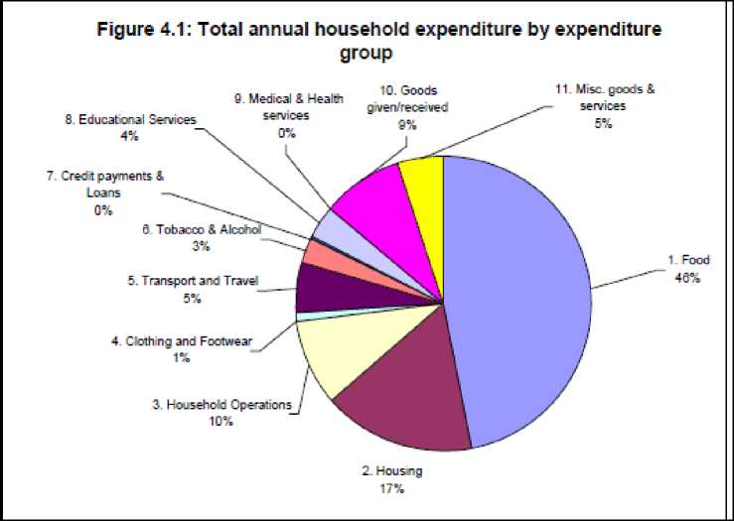

For both rural and urban areas of Kiribati, expenditure on food is substantial, comprising the major spending area (42% for urban areas and 52% for rural areas), as figures 4.2 and 4.3 below Illustrate.

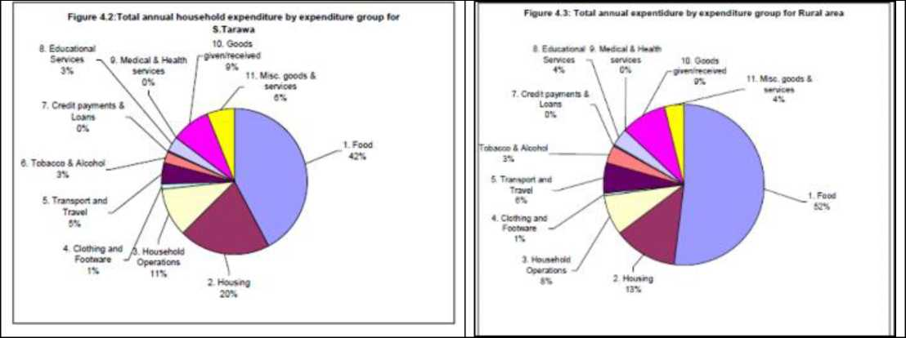

The expenditure for each household averaged around $9,400 per annum, with urban households (south Tarawa), spending around $13,000. For households in other areas of Kiribati, expenditure was substantially less at $7,000. See Table 4,1 below, taken from the 2006 HIES:

|  |  |  |  |
| --- | --- | --- | --- |
|  | | | |
| **Table 4.1: Average annual household expenditure by expenditure group for Urban/Rural** | | | |
| I III | | | |
| **Expenditure group** | **S Tarawa** | **Outer Islands** | **Total** |
| 1. Food | 55,537 | $3,749 | **$4,419** |
| | 2. Housing | $2,6B1 [ | 5910“[ | $1,574 |
| 3. Household Operations | $1,429 | $591 | $905 |
| **1 4.** Clothing and Footwear | $138 | $38 | | $76 |
| **1** 5. Transport **and** Travel | $624 | **5449** | $514 |
| 6. Tobacco & Alcohol | $339 [ | $24B-f | $282 |
| 7. Credit payments S. Loans | $13 | | $15 | $14 |
| **1** 8. Educational Services | **$443** | $273 | | $337 |
| 9. Medical £ Health services | 50 | $2 | **51** |
| **10.** Goods given/received | $1,158 | | $652~|" | $842 |
| **n** 1. Mise, g oods & services | $7B7 | $283 | | $472 |
| Total **Expenditure** | **$13,149** | **$7,211** | **$9,436** |
|  | | | |

Expenditure on food alone makes up about 46% of Kiribati’s total average expenditure or $4,400 dollars. Housing expenditure is also quite sizeable at 17%. There is not much being spent on medical and health expenses due to the fact that the government provides these services for free. Average household expenditure by group is illustrated Fig 4.4 below, taken from the 2006 HIES:

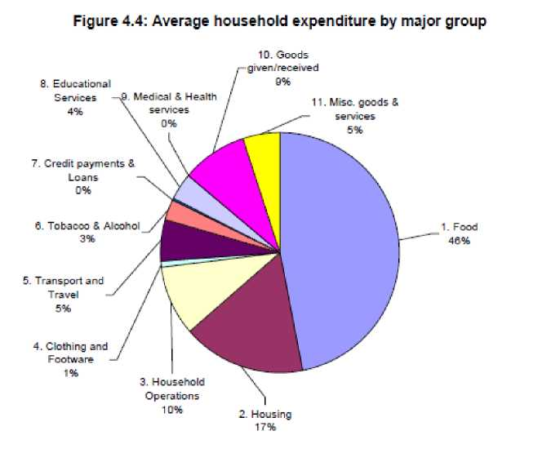

In Summary, annual expenditure exceeded annual income by some $10 million dollars. This discrepancy can partly be explained by people in both rural and urban areas, spending large amounts of money on big functions. Their contributions to these large functions are often funded through the use of loans and credits. However, the southern and central group islands had savings of over 1 million per year. These trends are shown in Table 5.1 and Fig 5.1 below from the 2006 HIES.

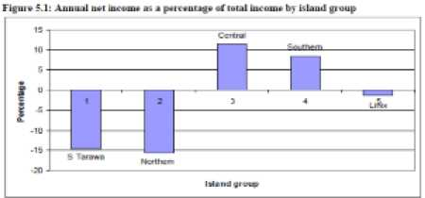

|  | **5 T BfMM** | **Northern** | **Central** | **Southern** | **Unix** | **Grand Total** |
| --- | --- | --- | --- | --- | --- | --- |
| **TOW income** | **60.127.766** | **20.066 657** | **11097 368** | **14 500.491** | **16.629.053** | **122,423 336** |
| **local Expenditure** | **68 967,626** | **23,177 364** | **9,634 318** | **13267 4£4** | **16 845,964** | **132,092.756** |
| **Net Income** | **-8 839,858** | **-3,106 707** | **1,263 050** | **1233 028** | **-216,931** | **-9,669 418** |

Table 5 1 Annual uec income by IsUud glinip

Households in Kiribati by and large exceed their income with expenditure by around $1,600 a year, which comes to around $60 a fortnight. Table 5.2 and chart 5.2 below break down the average household income and expenditure for each island group.

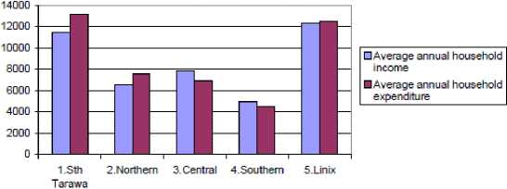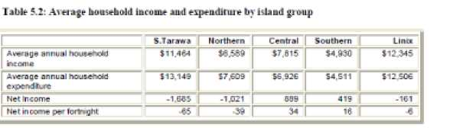

**Figure 5.2: Average annual household income and expendirure by island group**

Although a substantial number of people in Kiribati spend more than they earn, people in the central and southern island groupings buck the trend, saving $200 and $90 a year respectively according to the 2006 HIES.

4 The Tuvalu case study

* 1. The food that is consumed and its cost
     1. Imported food

Tuvalu imports some 3,100 tonnes of food annually with a cif value of around $4.2 million annually. Over the period 2010 to 2016, food imports averaged around 16% of total imports and oscillates yearly between 14% and 22%

*Table 8: Tuvalu Food Import - average for the period 2010 - 2016\**

|  |  |  |
| --- | --- | --- |
| Tonnes | CIF value | Consumption price/kg |
| imported | ($'000) | /capita (kgs) |

|  |  |  |  |  |
| --- | --- | --- | --- | --- |
| Rice and wheat flour and | 997 | 1,274 | 87 | 1.28 |
| wheat flour products |  |  |  |  |
| Sugar and confectionary | 525 | 452 | 46 | 0.86 |
| Edible oi l | 429 | 825 | 38 | 1.92 |
| Edible meat | | 433 | 653 | 38 | 1.51 |
| Beverages and spirits | 405 | 503 | 36 | 1.24 |
| Vegetables | 190 | 146 | 17 | 0.77 |
| Dairy products | | 100 | 263 | 9 | 2.63 |
| Fresh fruit | | 51 | 63 | 4 | 1.24 |
| Fresh seafood | 12 | 18 | 1 | 1.50 |
| Total | | 3,142 | 4,197 | 276 |  |

*Derived from the average for the time period 2010-2016, with data sourced from the SPC Prism Statistical Div.

* + 1. Rice, wheat flour and wheat flour products.

Rice and wheat flour constitute by far the largest imported food category with nearly 1,000 tonnes imported annually with cif value of around $1.3 million. Per capita consumption of rice and wheat approaches 90kgs per head. Some retail prices for grain and grain products observed in Funafuti in store in August 2019 were: $12 a 10kg bag Punjas (Fiji) flour; $19 for a 5 kg packet of Punjas breakfast crackers; $25 for a 40lb bag Calrose rice

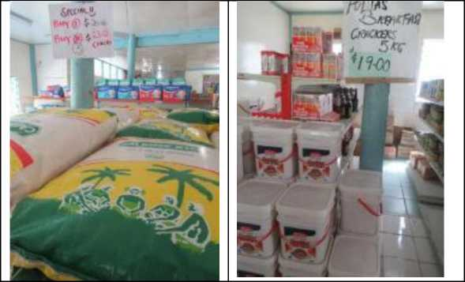

The local substitute for imported rice, wheat flour and wheat flour products are the traditional root crops (largely pulaka and taro) and breadfruit. The consumption of traditional root crops has been in marked decline. There is scope to significantly reduce the rate of decline of these traditional root crops and with considerable effort and investment possibly even toreverse this decline. Breadfruit is the product that offers the greatest scope for being a significant substitute for imported rice and wheat flour products. Breadfruit has been identified as one of the most climate resilient crops available - described as “a crop of the future” (Taylor et.al 2016). It is widely grown throughout Tuvalu and is amenable to yield enhancement through improved cropping practices (particularly pruning) and can be part of an appropriate agroforestry program along with coconuts and other traditional food crops (as demonstrated on Funafuti and Vaitupu). Breadfruit has been a traditional food source for millennia. Many of these uses continue today - including cooked mashed breadfruit mixed fresh grated coconut and fresh toddy served for breakfast (see picture below).

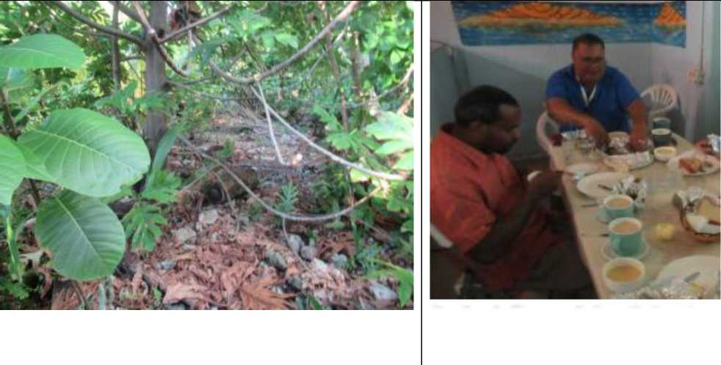

Enjoying a traditional Tuvaluan breakfast which includes cooked mashed breadfruit mixed fresh grated coconut and fresh toddy

Breadfruit being grown as part of the SPC sponsored Agroforestry block at the southern end of Funafuti

Breadfruit is also amenable to modern processing including the manufacture of chips (a substitute

for imported snack food) and most importantly it can be processed into high quality flour which is being done on a cottage industry scale at the Tutu Rural Training in Fiji (McGregor and Stice 2018 Annex 1) .

* + 1. 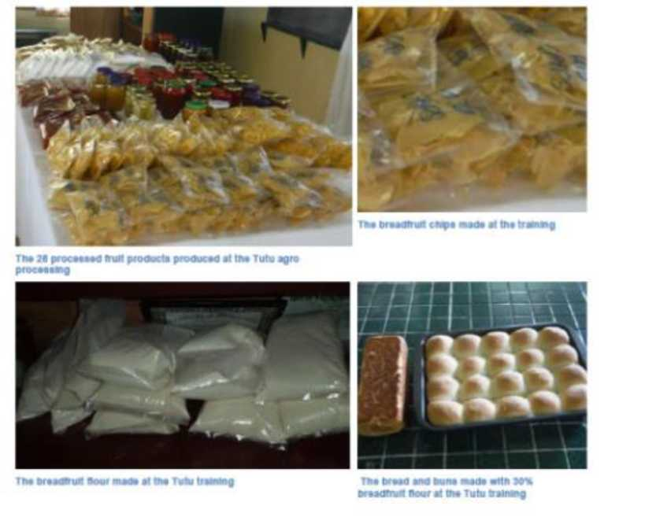Sugar and confectionary products.

A range of breadfruit products produced on a cottage industry scale by the Tutu Rural Training Centre, Taveuni Fiji (Source McGregor and Stice 2018 Annex 1)

Sugar and confectionary products make up Tuvalu’s second largest food import category - with around 525 tonnes imported annually (cif value of some $450,000). The annual per capita consumption of these products is around 46 kgs/head, which amounts to over 125 gms of sugar per head per day. To this has to be added the sucrose contained in soft drinks and fruit drinks. Observation and informal discussion indicated that it was not uncommon for 2 to 3 full tea spoons of sugar to be added to be added to cups of tea, coffee and milo.

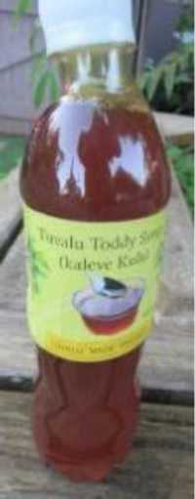This level of sugar consumption is a major contributing factor to exceptionally high incidence of NCDs and in particular diabetes. White sugar imported from Australia retails in shops for around $1.70/kg. Toddy syrup is locally produced sweetener. However, it would be unrealistic to expect toddy could replace a major portion of current sugar imports, and it would seem to be more of a substitute for the small volume of honey that is imported and for niche market exports - considering volumes involved and the high cost (labour input) of producing toddy. An appropriate intensive educational campaign, particularly in schools, on the ill effects and cost of high fructose consumption would seem to be the only way that any significant reduction in sugar inputs could be achieved.

* + 1. Edible oil.

Edible oil is the third largest food import category with around 430 tonnes imported annually (38 kgs/cap) with a cif value of around $825,000 ($1.92/kg). This compares with Fiji that imports around 17,000 tonnes of cooking oil or about 18.5 kgs/cap. The retail price of cooking oil ranges from $2.90 to $7.10/litre, depending on whether is palm oil, soya or canola oil. No coconut oil for cooking was found in any of the shops visited - even though it is the traditional source of cooking oil. According the 2016 HIES, coconut oil is the main locally produced product that is traded between Funafuti households. So, it is assumed this is on a household to house basis and not through retailed shops.

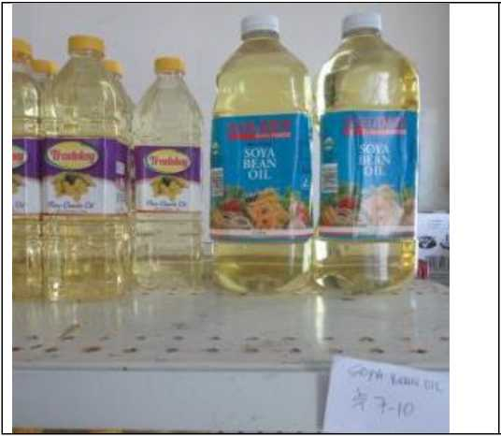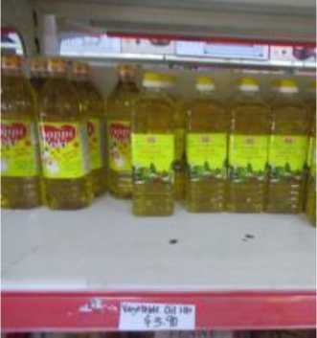

There is a major opportunity to substitute a significant proportion of cooking oil imports with food grade coconut oil - be it virgin coconut oil (VCO) or, more likely high-quality copra oil produced, by small direct micro expeller (because of its much lower input requirements. Both VCO and high grade copra oil can be successfully produced on a small scale - as shown for VCO made by the Banaban community on Rabi island Fiji and food grade copra oil by Chottu Coconut Products in the Solomon Islands (McGregor and Pelomo, 2018)**[31]**

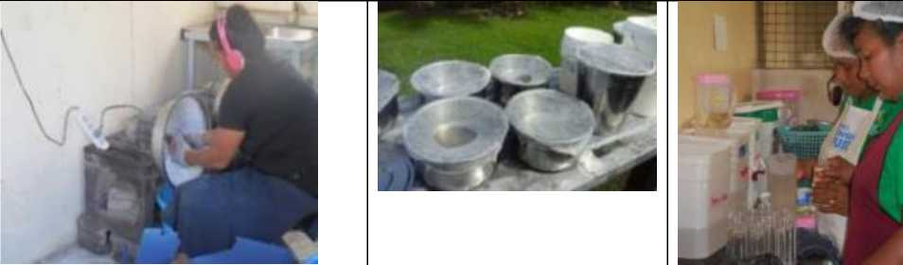

**VCO being manufactured on Rabi Island Fiji for the local market**

*Food grade copra oil being manufactured on a small scale by Chottu Coconut Products in the Solomon Islands for sale on the local market*

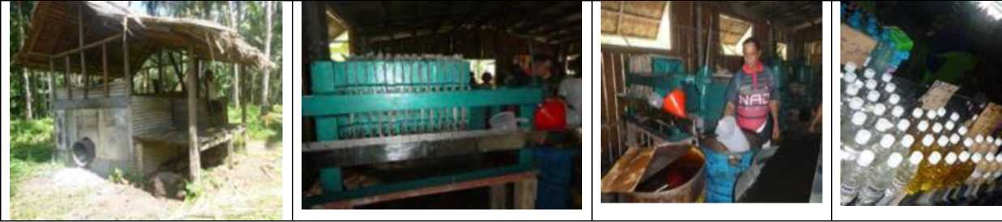

In the major coconut producing countries of the world, Philippines and Shri Lanka oil is widely accepted as a cooking oil. Lessons can be learnt from the experience of the Philippines in this respect, where VCO is now common as a functional food that can be readily purchased from supermarket and drug stores, packaged in 250- and 500-ml bottles (Balwalan 2011 p, 9)**34**.

The low level of domestic VCO in the PIC’s can be explained by a combination of factors; price, coconut oil’s reputation as an inferior product and the unfavourable labelling requirements for competing oils. In the Pacific islands coconut oil generally has a reputation as poor man’s inferior product compared with the other imported cooking oils. In Fiji the major imported oils (soya and canola) are subject to price control

regulations and incur zero tariff. In Tuvalu and Kiribati, local producers of VCO or edible copra oil would not face this constraint. In a number of major markets imported oils are subject to “trans” fat labelling regulation. However, such labelling is unlikely to be in place for Tuvalu and Kiribati for

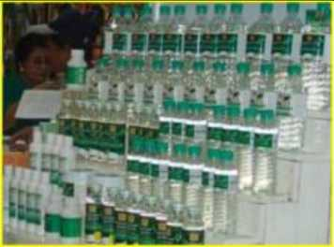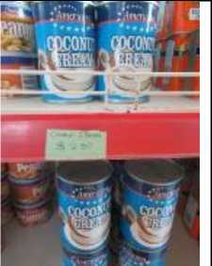

the foreseeable future.

Local VCO a mainstream product Manila stores (Source APCC 2017)

Imported coconut cream retailing in Funafuti

* + 1. Edible meat.

The fourth largest imported food category in Tuvalu is made up of beef, pork and poultry products. Some 430 tonnes of edible meat products are imported annually for an annual cif value of some $650,000.

34 Bawalan D. 2011. Processing manual for virgin coconut oil, its products and bi-products for the Pacific islands countries and territories. Secretariat of the Pacific Community, New Caledonia

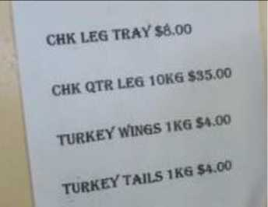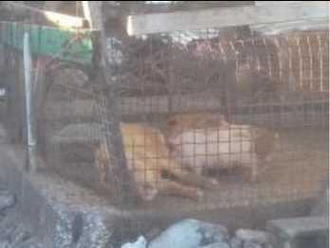

Lamb Neck: $11.50 a kg

Lamb cuts: $5.30/kg Pork Chops and Belly: $8/kg

Small piggeries on the ocean side of Funafuti

There would be modest scope to reduce these imports. Pork is the only significant meat product

produced on Tuvalu - with even a significant number of small piggeries maintained on the ocean side of Funafuti. There is a private sector proposal under consideration to establish a commercial scale piggery on Funafuti with 5-6 thousand pigs using the dry litter concept (personal communication Pulau Haulagi owner of Sulani and Chairman of the Tuvalu Private Sector Association). Biogas would also be produced from this and they would look to sell 25kgs bags of pig manure compost for $5/bag. There is scope to establish small scale poultry operations based on coconut product feed along the lines that the Farm Support Association (FSA)/Syndicate Agricole has successfully done in Vanuatu [https://brusselsbriefings.files.wordpress.com/2016/05/farmer-support- association-sapv-syndicat-agricole.pdf](https://brusselsbriefings.files.wordpress.com/2016/05/farmer-support-association-sapv-syndicat-agricole.pdf)

* + 1. Beverages and spirits.

Around 405 tonnes ($500,000 cif) are imported annually of a broad category of beverages. This includes bottled water imported from Fiji. There is probably limited scope for import substitution in this category. The one exception would seem to be green drinking coconuts. Drinking coconuts, commonly found for sale in urban centres throughout the Pacific islands. However, on Funafuti they are conspicuous by their absence. Any drinking coconut substitution for imported sugar laden soft drinks would bring with it significant health benefits.

* + 1. Vegetables.

Around 190 tonnes of vegetables are imported annually with a cif value approaching $150,000. A major component of vegetable imports is frozen root crops - frozen taro and cassava from Fiji and frozen cassava from Vietnam. According to an importer Pulau Haulagi (Chairman of the Tuvalu Private Sector Organization TNPSO) an average of a reefer containers of frozen taro and cassava is imported from Fiji per month. This amounts to approximately 10 tonnes per month or a 120 tonnes per year or some 60% of the total “vegetable “imports. This frozen taro and cassava currently retails in a number of the Funafuti shops for around $6.90/kg for taro and $5.90/kg for cassava. It is reported that the fob price in Fiji for the frozen cassava is $F2.50/kg. This suggests that there is a large margin which could enable locally grown root crops to be competitive despite the relatively high production costs.

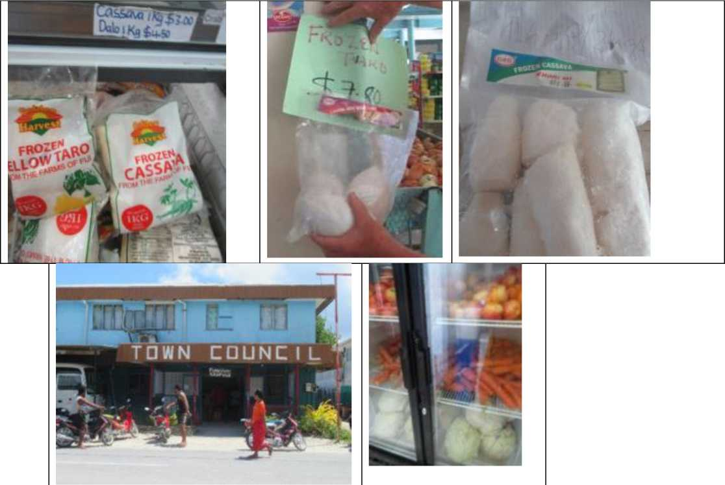

Funafuti Kaupule (Local Council) building. A designed area outside the building is proposed as a location

No local produced taro or cassava is formally sold in Funafuti either in retail stores or road side markets. Road side stores are currently non-existent on Funafuti. Pulau Haulagi is selling locally sourced fresh taro and cassava, initially grown in Vaitupu, in his Sulani Company Store adjacent the Funafuti Kaupule (Local Council) building and the Funafuti “town market” where the bread market is located. Pulau believes the grower could also sell independently in the space provided outside the Kaupule. This would seem to be a reasonably attractive opportunity, with current retail prices for frozen imported taro and cassava approaching $7 and $6 per kg respectively, despite the relatively low yields achieved and the high labour inputs required. Past efforts to secure taro and cassava from Vaitupu and other outer islands were unsuccessful due to a number of factors: These included: unrealistically high price expectations of the grower; unreliable shipping and high transportation costs from the outer islands; and the grower not being formally linked to a buyer in Funafuti (per communication Itaia Lausaveva - former Director of Agriculture and now the Secretary of the TNPSO). There is certainly a substantial demand on Funafuti for locally grown taro and cassava given the high level of frozen imports. Based on discussion with Pulau Haulagi and Itaia Lausaveva the supply constraint, at least for Vaitupu, could potentially be overcome by a combination of measures. These include:

* Formally linking selected growers to a buyer - through an appropriate “contract” farming arrangement
* Coordination between the buyer and the grower regarding when the ship is actually departing - at which time the grower can harvest the required volume of product. This has now become more feasible with the increased use of mobile phones.
* Awareness training for the growers of the cassava and taro value chain. This is so they understand what each actor in the chain contributes to the final produce, the costs they incur and the reward they receive (see PIFON 2016 and <https://pacificfarmers.com> > resource > value-chain-training-impacts)
* Supplying of the growers with appropriate cartage crates to minimise post-harvest losses.
* The Government owned shipping could provide highly subsidized or even free shipping root crops from the outer islands to Funafuti to initiate the start-up of the value chain

Based on instore observation the other imported vegetables largely consist of potatoes, carrots, onions and English cabbage, chillie and capsicum. Onions and potatoes retail in stores for around $3.30 a kg, carrots and English cabbage for around $5/kg, chillie and capsicum ($14/kg) .

There has been some input substitution in vegetables thanks to the effort of the Taiwan Technical Mission (TTM). TTM started operations in 2003 and has a .3 ha introduced vegetable and fruit garden on Funafuti and 3 ha garden on Vaitupu (which largely supplies the Tuvalu High School. The main crops grown are cabbage (Chinese and English), cucumbers, capsicums, tomatoes and chillies. These are sold to the public on Funafuti every Thursday and Saturday morning - with revenue earned paid to the Tuvalu Government. The selling prices in August 2019 were: cucumbers ($3/kg); tomatoes ($8/kg); chillie and capsicum ($8/kg). They average 80 to 100 customers per session who buy around 2 to 3 kgs of vegetables each and who queue early in the morning for access. The demand for these fresh vegetable clearly exceeds supply

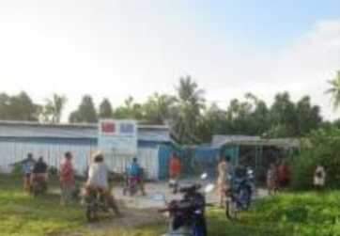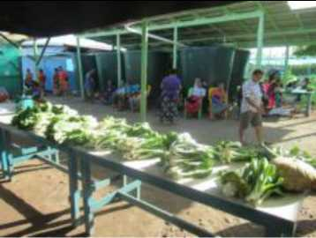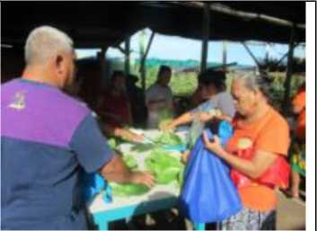

Customers queuing early Saturday morning before the opening of the TTM vegetable market.

The available vegetable supply being rationed amongst the registered customers

The customers collecting their allocated ration of vegetables - a process that takes around 1 hr.

In addition, thanks to the effort of the TTM, the NGO Live and Learn and the independent initiative

of households there are some home gardeners on Funafuti (including the island Funafala), who grow

vegetable and fruit for their own household consumption. These home gardeners give any surplus to their extended family. Considerable scope has been identified for increasing home garden fruit and vegetable production and this needs to be a priority.

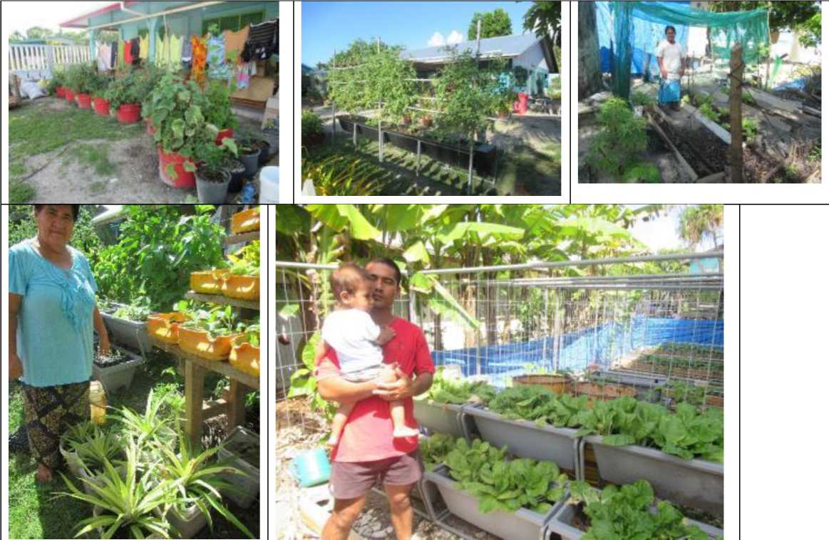

**Some of the productive home gardeners found in urban Funafuti.**

* + 1. Dairy products

Around 100 tonnes of dairy products are imported annually for a value of some $260,000. A range of coconut milk and cream products remain the traditional substitutes for dairy products. On one hand, there is scope for increasing the level of import substitution. However, it is of note that included in Tuvalu’s imported food products, is coconut cream imported from the Philippines and retailing at $2.50 for a 600 ml can (see picture above). This imported coconut cream is apparently regarded by consumers as a distinctly inferior product compared with locally produced coconut cream. However, it has a market on Funafuti for the convenience it offers. Also, Funafuti residents who are from the outer islands often do not have access to an adequate supply of fresh coconuts. Thus, there is clearly an opportunity for the outer islands to produce coconut cream for sale on the Funafuti market.

* + 1. Fresh fruit

Some 50 tonnes of fresh fruit are imported annually with a cif value of about $60,000. These comprise entirely temperate fruits (with their current retail price in brackets: apples ($6.50/kg), pears ($6.20/kg) and oranges ($6.20/kg). These are particularly high prices for consumers for products that seem to be well below their use by date shelf life. These temperate fruits cannot be realistically grown in Tuvalu.

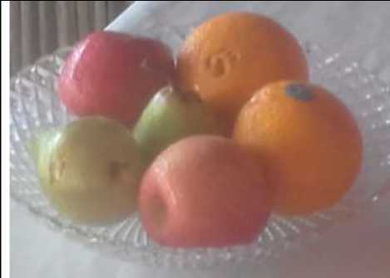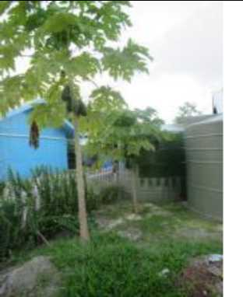

**The fruit occasionally on offer at Funafuti’s main hotel**

**A home garden growing papaya with seedlings source from TTM**

However, apart from traditional fruit (eg banana, pandanus and fig) there is scope for increased import substitution with the growing of introduced tropical fruit. Some success has been achieved with papaya from Taiwan. It would be worthwhile obtaining certified “Fiji Red” papaya seed from Nature’s Way Cooperative (Fiji) Ltd. Seed could then be selected from the trees that performed best in the conditions that prevail in Tuvalu**[32]**.

TTM is now trialling dragon fruit - that is yielding some results. As a cactus that is grown in direct sun and derives its nutrients largely through its leaves (epiphytic) it would seem an ideal crop for the harsh prevailing conditions. Pineapples are a crop that have more current attention as outlined in the “Crop Development Handbook for Agricultural Workers in Tuvalu”. While pineapples require adequate composting for plant establishment, the ongoing nutrients for plant growth and fruit development are acquired through foliar sprays (including the application of appropriate compost tea).

Another epiphytic crop, but even more so is vanilla. Vanilla derives its nutrients entirely through its leaves . Vanilla requires extensive dry mulching and the ideal dry mulch is coconut husks (Bianchessi 2012). These and other conditions would be favourable for its production in areas of Tuvalu. Vanilla would, of course, not be for local food consumption. However, it offers a potential opportunity as a high unit value non-perishable export product. By increasing Tuvalu’s export earning it contributes to food security as defined by FAO’s Food Import Capability Index (FICI). Tuvalu, along with Kiribati, has amongst the highest FICI of any country in the world - making it one of world’s least food insecure countries.

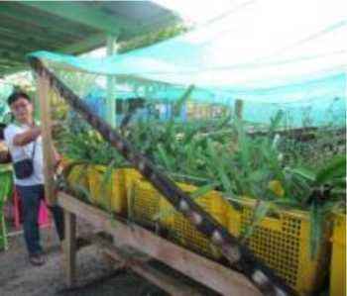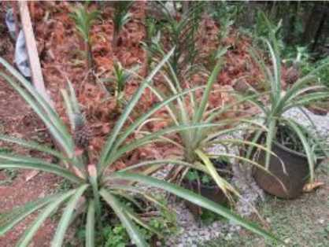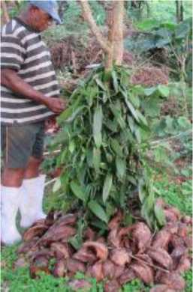

**Dragon fruit planting material at TTM’s Funafuti garden**

**“Ripley Queen” pineapples grown with compost in pots by home gardeners**

**Epiphytic requires plenty of dry mulch for the leaves - coconut husks are an ideal material**

* + 1. Fresh seafood

A little more than 10 tonnes of fresh sea food are imported annually. This small level of inputs is hardly surprising, as fresh seafood remains one are area where Tuvalu continues to be almost fully self-sufficient. This applies to both the outer islands and Funafuti. On crowded Funafuti, most of the population that has come from the outer islands does not access to land to grow their own food. This constraint applies far less for access to harvest fresh sea food.

* 1. The food that is produced locally

Tuvalu is yet to hold an agricultural census, and conducting an appropriate Agricultural Census is identified as a priority. However, some useful questions on agriculture were included as part of the 2012 Population Census. In additional some particularly useful information was gleaned from the 2015/16 Household Income and Expenditure Survey.

The 2012 Population Census provides an indication of the number of households that have particular crops (table 9). Coconuts were, and still are, the dominant food crop with well over 80% of rural households and some 60% of Funafuti households growing coconuts. For rural households was found to be the next most import crop grown. At the time of the Census, 80% of rural households grew pulaka - but just less than 10% of Funafuti households (this number has likely fallen significantly since then). After coconuts and pulaka the next most important crops in terms of the number of households growing them are breadfruit, bananas, taro and pandanus - all being significantly more important in the outer islands. All these crops are largely grown for subsistence (self-sufficiency) purpose as illustrated by data collected in the 2012 Population Census shown in figure 5.

**Table 9: Percentage of Households growing various crops by area**

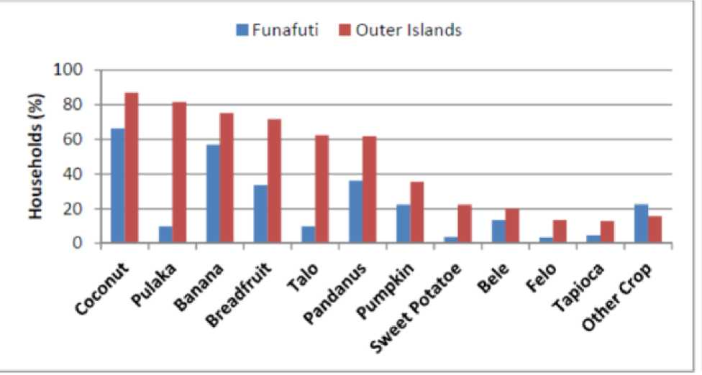

**Fig 5: Purpose for growing various crops by region and type of crop**

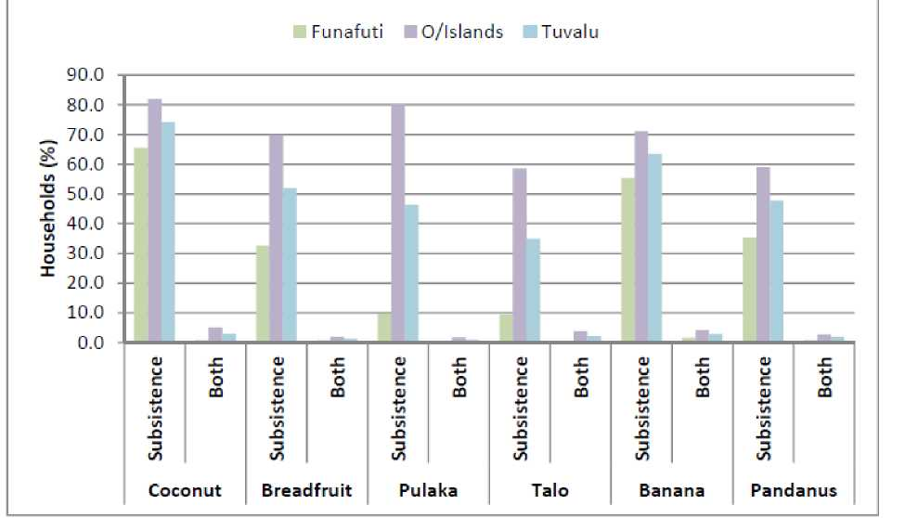

According to the 2015/16 HIES, 89.6% of households (HH) were involved in at least one primary activities (agriculture, fishing, livestock and handicrafts) for subsistence. The percentage for Funafuti was 79.8% and for the other rural islands 89.6% (p, 46). Fishing and livestock (pigs) are the dominant subsistence activities on both Funafuti and the rural islands (table 10). However, on the rural islands, agriculture remains an important subsistence activity with 80.7% of households involved - this compares with urban Funafuti where only a mere 15.6% of households are involved in some subsistence agricultural activities. This compares with 69.5% and 31.5% of Funafuti households involved in subsistence livestock and fishing activities respectively Very few Funafuti households are involved in any agricultural activities for cash (only 2.2%). The figure is slightly higher for rural households (7.4%). The involvement of households for cash is somewhat higher with fishing and livestock. In terms of fishing, 5.1% of urban households and 14% of rural households; and for livestock, 6.9% of urban households and 14% of rural households.

*Table 10: HH participation in primary production activities (agriculture, fisheries, livestock and handicraft (source: table 46 HIES)*

|  |  |  |  |  |
| --- | --- | --- | --- | --- |
|  | Urban | | Rural | **Total** |
| Primary activities | Cash & subsistence | 79.8% | 98.2% | 89.6% |
|  | | | | |
| Agriculture | Cash & subsistence | 15.6% | 80.7% | 50.5% |
| Fishing | Cash & subsistence | 31.5% | 75.2% | 54.9% |
| Livestock | Cash & subsistence | 69.5% | 95.1% | 83.2% |
| Handicraft | Cash & subsistence | 15.9% | 38.4% | 27.9% |
|  | | | | |
| Agriculture | Cash | 2.2% | 7.4% | 5.0% |
| Fishing | Cash | 5.1% | 14.0% | 9.8% |
| Livestock | Cash | 6.9% | 12.2% | 9.7% |
| Handicraft | Cash | 15.6% | 31.3% | 24.0% |

* 1. Coconuts
     1. 3 Self-sufficiency from coconuts

Coconuts, along with sea food, have traditionally been Tuvalu’s most import food sources. This still remains the case for subsistence food. As shown in the table below coconuts in Tuvalu have a myriad of traditional uses, many of which are still valid for today’s food security at least with respect to outer-island households.

A survey conducted by the Tuvalu Census Department in the late 1990s, found that the average household in the outer islands consumed 18 coconuts per day and those on Funafuti 10 coconuts per day (McGregor and McGregor 1999). The number of coconuts consumed on Funafuti has probably fallen from that level due to increasing population and the declining productivity of the aging coconut palms. According to data collected as part of the 2012 Population Census, a high percentage of households still continue to make toddy on a regular basis as shown below.

An estimated 2,100 ha, or around 70% of Tuvalu’s cultivable, remains under coconuts. A high percentage of these palms are well over 60 years old (probably well in excess of 50%), with the younger palms derived from self-seeded nuts that have not been harvested. These old palms are classified as senile and are well past their most productive life. They are now highly susceptible to being broken by a tropical cyclone - even of a category 2 or 3 strength. There is now an urgent need for a systematic coconut replanting program to be implemented in Tuvalu, as it is in all the atoll countries.

|  |  |  |
| --- | --- | --- |
| **Coconutp«1** | **Tuvaluan Terwi** | **DoecrMon** |
| **Huts** | **• 0 - .** | **Only tar dnrtmg wteioutMM** |
| **uto** | **Fer frwong tamd *and* MS otton** |
| **3** | **The (tmiung nut «<h ho tot MM feroued by youig and old *fao* used tor cootag as wei as tar foodno to Mm and** mi **Hua it used tor matano cocontt tore anno and ateo tar ttftounttng the oarfo oven rttrd mil used as a coMmer n the oorth own** |
| **motjmofo** | **Wto *a* harder »M md tftdtar MM Ths typo a used for tood and fodder tar** pm **thata are teemse used as toad coroners r the earth oven** |
| **Futrt«i** | **The ape nut KarM eaten raw used grated and pressed n cooteng (cocorut »M| and tar bortr oi cocrt 1M0 tar oabnol and tar** oq **fodder Huet used at contouatfote mateM tar or at ’aorta’ or voosoto at tasks for ol as marten dune osmes flatol hooka and corvfouetote mataM** |
| **dbnu (pc/acutei** | **The germneing nut Contente eaten raw and used tar cootong** |
| **teume** | **For the {roducton of tee-brandi and fas tongs** |
| **lntlorv*«nc«** |  | **Cut to otter toddy** |
| **loom** | **MW** | **The young toot before it uMds used for eeemg lane and beauts and tar tymg Arte** |
| **tazsu** | **Green bonds used tor wearng tocr mots tood ptetet ooveang and bets tor games tar tyng suts tar beds tar those oho cimb pate tees tar mage tor ‘wmd-mf toys end tar wrappmg around feh bang put n an earth oven** |
| **tawtemo** | **Ota brown bonds used tor birds food pates rooting torches for tahmg corearers for compost 1ptetad and womd randi starts garland of towers compost and cortusttte moteM** |
| **UutMnci** | **Itidnba *d* the frond toitecs used tar brooms *a««mg the pendarvs teases furnng tie tegmenta of hatch, bosUte tana ’wm^mdt’ and toy canoes tor sr enghonng tie tries of borvto hocu as sUwors tor cootang Seb and as ’anowe’ tar ihootng tan** |
| ***(Mata*** | **Frond mdnb when green used at a pete tar carrying for stmng food as a weapon n mock IgM at an improvised oocoru grater feifi coconut diet I. as an mprowted tool tar huterg cocontts as watsmute and outette ho houses, pwcet are used as toy dappers and when spa used at *a* baft tar earring tah When otd and grey used *aa* rott patems. as ho support tar the pondanus tooses used n he tegmenta of tuten tar the ptodonn r stoepmg houses tor strong tood tar** mH **coeonng room parttoons and at oontoutatte meterui** |
| **Ma** | **Houai tore doth bcm tie base of the loaf steh** |
| **(lauMaJ** | **used as *a* Nter beg tor grated cocorut meat body at as hartal medone as a War tar toddy as indar when mat ng a tea and as confouslfato mteer W** |
| **SlKfl** | **topsruMM** | **Used as support ng posts or beams tor houses tor rod besom house surrosrds spo<s props PMh tonces and fool tor tato*taensig** |
|  | **feaA c? petal** | **Used as an ngrwdert for scoring body cd tar smos ng mate and as combustole mater wM** |
| **Root!** |  | **Used tar tab tape sand screens and modone** |



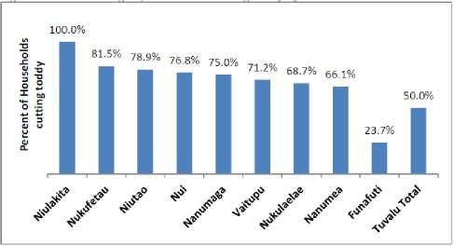

Table 3: Percentages of households cutting toddy by Island

**Source: Tuvalu 2012 Population and housing census**

The 2015/16 HIES ranks coconuts nationally as the most important in terms of subsistence “income” - calculating that 35.6% of subsistence “income “comes from coconuts (table 11). However, the HIES shows that there is a huge difference been the subsistence income coming from coconuts on urban Funafuti and the rural outerislands - 0.8% for Funafuti, compared with 39.1% for the outer islands.

*Table 11: The proportion of total subsistence income from the top 10 products, by strata (source HIES table 48)*

|  |  |  |  |  |
| --- | --- | --- | --- | --- |
|  | | Urban | Rural | Total |
| 1 | Coconut | 0.8% | 39.1% | 35.6% |
| 2 | Reef fish (parrot fish, snapper, moonfish, etc) | 24.1% | 14.0% | 15.0% |
| 3 | Breadfruit | 2.2% | 9.4% | 8.7% |
| 4 | Crabs | 0.5% | 7.0% | 6.5% |
| 5 | Toddy | 6.1% | 6.4% | 6.3% |
| 6 | Tuna (skipjack) | 16.6% | 4.4% | 5.5% |
| 7 | Taro | 1.5% | 5.6% | 5.2% |
| 8 | Pig | 33.5% | 2.1% | 5.0% |
| 9 | Wild birds (gogo, lakia) | 0.0% | 5.1% | 4.6% |
| 10 | Banana | 7.1% | 3.5% | 3.8% |
| Total | | 92.3% | 96.7% | 96.3% |

* + 1. Cash income earned from coconuts

Copra was the main source of rural household income until 2011. This income ceased however in 2011 with the termination of government funding for Tuvalu Copra Co-operative Society. In Kiribati copra remains the main source of cash income derived by rural households thanks to the continued operation of a highly subsidized subsidy scheme. In Tuvalu, currently the only export income earned from coconuts is from the small volume of red toddy (toddy syrup) exported to New Zealand. There are, however, apart from red toddy a number of niche market export opportunities being developed for coconut products. These include virgin coconut oil (vco), and coconut jam. Despite the loss of copra earnings, coconuts still provide the most important source of the meagre cash income derived from primary activities (agriculture, fisheries, livestock and handicraft products). The 2015/16 HIES found that coconut oil for cooking ranked as the most important cash income derived from primary activities - with 36% of urban households primary earnings for cash came from selling coconut oil for cooking (table 12). Given the high quantity of cooking oil that imported (around 430 tonnes imported annually - 38 kgs/cap) there is a substantial opportunity to expand these sales if food grade coconut oil is produced and marketed. Further down the ranking of income primary activities is whole coconuts for sale and coconut oil for hair and body - with 3% of households earning income from these activities. These products to would seem to have potential for expansion. The selling of green drinking coconuts in Funafuti is seen as one excellent opportunity.

*Table 12: Proportion of total cash income from the top 10 agriculture, fisheries, livestock and handicraft products, by strata (source: table 47 HIES)*

|  |  |  |  |  |
| --- | --- | --- | --- | --- |
|  | Urban | | Rural | Total |
| 1 | Coconut oil (cooking) | 36% | 10% | 15% |
| 2 | Tuna (skipjack) | 5% | 12% | 11% |
| 3 | Other Root crops (note) | 0% | 11% | 9% |
| 4 | Baskets | 3% | 9% | 8% |
| 5 | Tuna (yellow fin and bigeye) | 4% | 8% | 7% |
| 6 | Pig | 6% | 6% | 6% |
| 7 | Soft drinks / juices | 9% | 5% | 5% |
| 8 | Takeout food/sandwich | 4% | 3% | 3% |
| 9 | Coconut | 0% | 3% | 3% |
| 10 | Coconut oil (hair and body) | 4% | 2% | 3% |
| Total | | 70% | 68% | 69% |

* 1. Root crops

The relative import of the various root crops grown on Tuvalu can be gleaned from the data collected as part of the 2012 Population Census (Table 13_ below). Root crops are overwhelmingly

grown in the outer islands with pulaka being by far the most important. At the time of the 2012 Population Census, around 85% of households grew pulaka compared with 60% of households growing taro, 20% growing sweet potato and about 10% growing cassava.

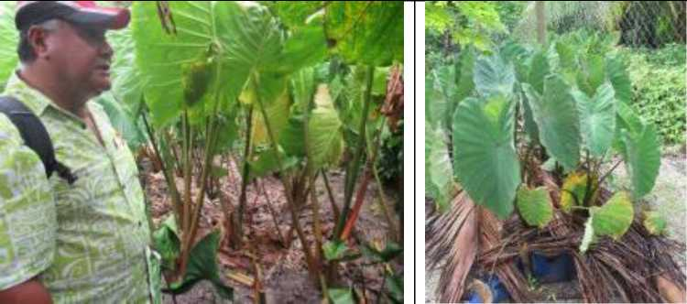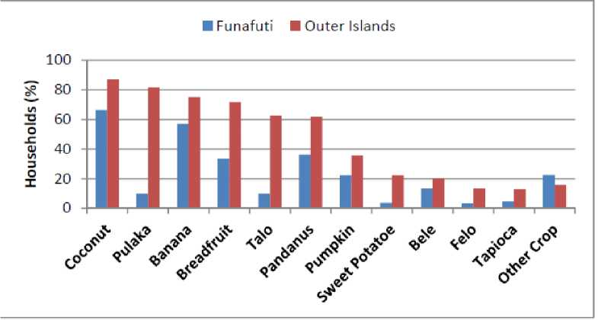

**Pulaka growing in one Funafuti’s three remaining operation pulaka pits with the former Director of Agriculture Itaia Lausaveva**

**Taro being grown in compost in above the ground containers on the Funafuti atoll island of Funafala**

**Table 13: Percentage of households growing various crops by area** (Source: 2012 Population Census)

Self-sufficiency from root crops

4.4.1

Based on the findings of the 2015/16 HIES, the contribution of root crops to self-sufficiency is small. The HIES estimates the value of subsistence to household income is only 8% of total income - 18% for the rural islands and 1.1% for urban Funafuti. Root crops share of the total attributed value of subsistence is in turn a small 5.6% in the rural islands and 1.5% on Funafuti (HIES 2015/16 p, 44). However, these figures do not capture the substantial health and nutrition benefits of consuming traditional local foods and the costs associated with the over consumption of the imported substitutes. This includes substantial public sector health costs.

4.4.2 Cash income earned from root crops

Currently there is non-quantifiable trade in domestically produced root crops. Only imported taro and cassava are available in stores. There are no municipal or road side markets selling produce grown by local farmers

* 1. Breadfruit

As previously discussed, breadfruit is probably most climate resilient of the main food crops grown on the atolls. Tuvalu has a number of popular varieties both seed and seeded - including the highly regarded Samoan variety *Ma’afala*. This has enabled the fruiting season to be extended for around eight (8) months. Breadfruit is seen extensively along the streets of Funafuti and throughout rural areas. According to data presented in the 2012 Population Census 70% of rural households and some 30% of urban households have breadfruit trees

■ Funafuti ■ Outer Islands

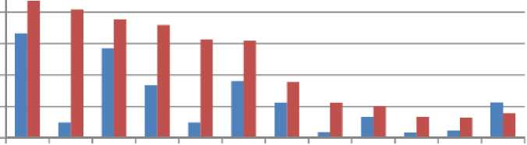

100

80

2 60

**O**

| 40

£ 20

0

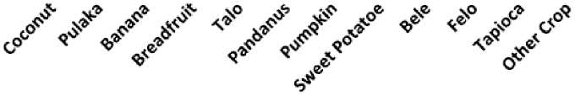

Breadfruit is boiled or cooked in an earth (umu) oven. It is also combined with grated coconut, coconut cream or toddy to make a number of dishes. It is now commonly sliced and fried to make breadfruit chips for home consumption

* 1. Introduced fruit and vegetables

The 2012 Census provided the following data on the number of households that were growing introduced fruit and vegetables. The census also provides information on the total kgs grown per week from each household home garden. These figures would seem to be an overestimation of the current situation, based on observation from the field work undertaken on Funafuti in August 2019.

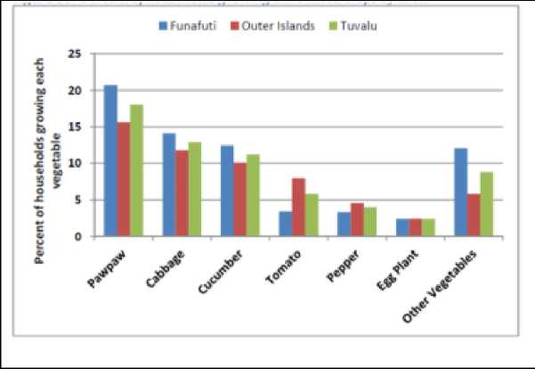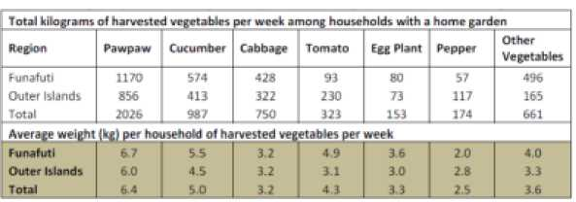

* 1. The marketing system for locally produced food

The small volume of cash sales in local produce that exists is entirely informal trade between households. No locally produced food is sold in stores and physical markets where locally produced food is produced currently do not exist. This includes small informal “road side” stalls.

Currently the only local market for locally produced fruit and vegetables is the TTM market on Funafuti. It operates on-site every Thursday and Saturday morning, and, as previously discussed, the demand for produce well exceeds the supply. No produce grown by the Funafuti population is sold at these TTM markets - although they are welcome to sell there if they so wished. An effort was made in the past to establish a local produce market at the Funafuti Kaupule (Local Council) building. However, this was not successful at the time. A fish market currently exists at this site along with a Kaupule operated bread shop. However, it is reported that the fish market rarely trades. In keeping with The Tuvalu Agricultural Strategic Marketing Plan (TASMP) 2016-2025, a renewed effort to establish and sustain a basic marketing infrastructure is required and adequate resources to do so need to be provided

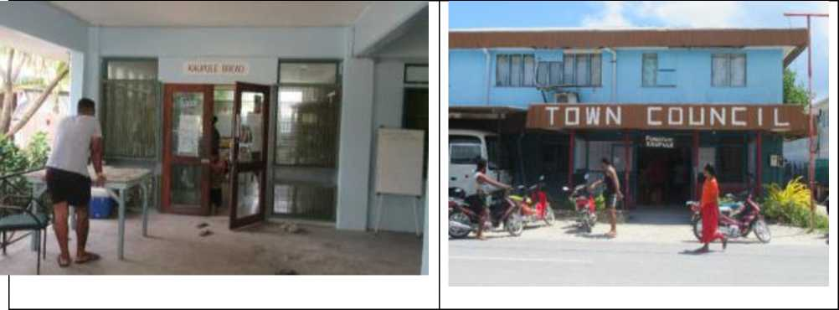

* 1. Advantages and disadvantages for local food production
     1. Advantages

**A substantial fisheries resource with an intact culture for its utilization.** The evidence of this can be found in the found in the HIES. This includes the population from the outer islands who now live on Funafuti but have don’t have access to land to grow food.

**The main terrestrial food crops (coconuts, breadfruit, pulaka, bananas and pandanus) for Tuvalu (and Kiribati) are relatively tolerant to climate extremes.** However, substantial public sector investment is required to safeguard and, where possible, increase the resilience of these traditional crops. This includes:

* Major public sector investment in a coconut replanting program. This is identified as a

priority, but neglected, climate change mitigation strategy

* The sustained development of appropriate agroforestry blocks built around coconuts, breadfruit and traditional fruit tree crops. This builds on what has commenced with the SPC/EU Project “Improving Food Security in Tuvalu through Developing Sustainable Agroforestry Systems” in both Tuvalu and Kiribati
* A scaling up of the SPC Centre for Pacific Crops and Trees (CePaCT) Program to introduce, test and distribute traditional crops that have greater salinity tolerance.
* Investment in physical barriers to reduce salt water incursion into vulnerable pulaka pits that are still being utilised.

**The high cost of imported food products is expected in the future to increase in real terms.** Because of Tuvalu and Kiribati’s isolation, the cost of imported food is exceptionally high - particularly food that is transhipped to the outer lands. A sample of current prices for selected basic food items on Funafuti is provided above. The current cost of shipping a dried container from Fiji is currently USD 2,000 and from New Zealand USD 5,800. For a reefer (cool) container a further 50% needs to be added to shipping costs. Air freighting food to Tuvalu is not an option as there only two small aircraft flight weekly from Fiji. Climate change is projected to have a greater impact on imported grain products (rice and wheat flour) than traditional Pacific island staples such as breadfruit. As a result the real price of imported grain products is projected to increase in real terms relative to Pacific island staples**36.** This projected price increase will intensify further the

already extreme food insecurity of atoll countries. However, it also increases the relatively competitiveness of some traditional stable substitutes - particularly breadfruit. This offers a major potential advantage for domestic food production if the appropriate necessary support is provided.

**Most of the islands have a favourable pest and disease status.** Tuvalu and Kiribati’s relative isolation means that they tend to be largely free of major agricultural pests and diseases. A seriously damaging fruit fly is only found on one of Tuvalu’s outer islands. Thus, fruit flies do not

36 These price projections are analyzed in detail in Chpt 9. Taylor et. al. “Vulnerability of Pacific Island agriculture and forestry to climate change”. SPC/Australian Aid 2016. [https://www.sprep.org/attachments/VirLib/Regional/vulnerability-pacific-island-agriculture-forestry-climate- change.pdf](https://www.sprep.org/attachments/VirLib/Regional/vulnerability-pacific-island-agriculture-forestry-climate-change.pdf)

impact on the production of important food crops such as breadfruit. Taro leaf blight, the extremely damaging pest found in taro in Samoa and PNG, is not present in Tuvalu or Kiribati. Nor is the damaging taro beetle that is found in Fiji and Vanuatu Tuvalu and Kiribati do not have the serious strain of coconut rhinoceros beetle that is currently so detrrimental to coconut production in the Solomon Islands and now Vanuatu. Papaya ring spot virus that has devastated papaya production in Hawaii is not present in Tuvalu or Kiribati - nor in Fiji a potential source of papaya planting material. This important advantage needs to be maintained through stringent and appropriate biosecurity control and community education.

**Appropriate technology that is being introduced for via TTM and other organizations.** The Taiwan Technical Mission (TTM), has been in operation in Tuvalu and Kiribati for more than a decade. TTM introduced appropriate vegetables and fruit that can be grown under the harsh environmental conditions that prevail in these atoll countries. In Tuvalu, TTM has developed appropriate cropping and composting systems at its two farms, located on Funafuti and Vaitupu. It has extended this knowledge to local households and provided quality seedlings. This knowledge is now being extended to the wider community through organizations such as the NGO Live and Learn. This work has the support of the Department of Agriculture and the various island Kaupule (Local Councils). It has the official endorsement of the Tuvalu Government through TASMP 2016 - 2025.

SPC and the Australian Centre for International Agriculture Research (ACIAR) have also been active. Appropriate agroforestry systems have been piloted by SPC in collaboration with the Department of Agriculture with successful preliminary achieved. In Tuvalu, this work need needs to be continued at the existing sites on Funafuti and Vaitupu and initiated on other islands. Tuvalu has been one of the participating countries in the ACIAR Project “Improving soil health, agricultural productivity and food security in atolls”(ACIAR SMCN-2014-089). However, the emphasis to date has been on Kiribati. The project has undertaken valuable applied research which has included: evaluating soil improvement technologies; evaluating for salinity tolerance and productivity germplasam supplied to island countries by SPC CePaCT; soil and compost evaluation; compost pot trials; evaluating the performance of introduced fruit and vegetables; irrigation trials and pest and disease research. Project outputs have included: fact sheets about nutritious leafy green vegetables that are available but underutilized; compost “recipes”; and information about producing productive soil from locally available input material. This particular ACIAR Project will conclude in December 2019. However, this work, after a very useful start, needs to be continued and extended to the wider community. This is necessary if there is to be a significant, sustained impact.

A major constraint identified is the current lack of major raw material sources to make the volume of compost required to produce the of local food necessary have significant impact on food security.

The inner core of “senile” coconut palms is identified as one such source that now needs to be utilized on a substantial scale. There would be substantial secondary benefit arising from a major coconut replanting program for coconuts. Quality hardwood would be available from the outer core of felled coconut palms needed for the construction of raised planter beds. Another major source of compost material that appear not to be utilized, at least in Tuvalu, is seaweed. Seaweed provides an excellent ingredient for both soil compost and as foliar spray (compost “tea”).

There is need to test more appropriate local sourced material for raised planting bed for fruit and vegetables. In Tuvalu, full utilization of halved used 44-gallon drums and used polypropylene bags

does not appear to being made. In addition, the outer core of felled senile coconut palms would provide an excellent timber source for building raised beds.

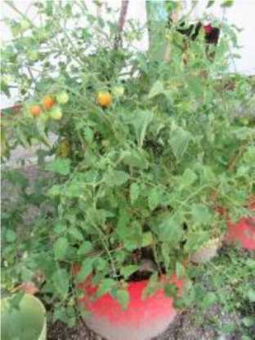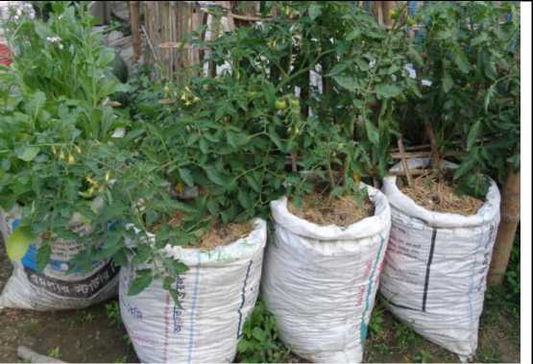

**Halved used 44 gal drum used to successfully grow tomatoes by home gardener in Funafuti**

**Used polypropylene bags used for growing tomatoes.** Source: **World Fish. Vertical agriculture: Homestead horticulture suspended in sacks [https://www.worldfishcenter.org/content/vertical- agriculture-homestead-horticulture-suspended-sacks](https://www.worldfishcenter.org/content/vertical-agriculture-homestead-horticulture-suspended-sacks)**

4.8.2 Disadvantages

**A particularly weak value chain for trade in domestically grown food crops.** In Tuvalu, there is no formal trade in domestically produced food. Locally produced food is not available in stores and that there are currently no produce markets (including rudimentary informal road side stalls). A fundamental weakness in the value chain appears to be the lack of private sector involvement. Prior to 2011, there was some trading in local produce from the outer islands through the Tuvalu Copra Co-operative Society, which also purchased. The Cooperative ceased operations with the termination of its government funding. There are now, however, encouraging indications of the private sector wanting to be become involved in the trade of locally grown food. This was revealed in discussions with current Chairman of the Tuvalu Private Sector Organization (TNPSO), together with the former Director of Agriculture who now also serves as the TNPSO Secretary. The TNPSO Chairman’s company currently imports frozen taro and cassava from Fiji. This is retailed at the company’s Funafuti shop as well as being wholesaled to other retailers. On average of one (1) reefer container of frozen taro and cassava is imported from Fiji per month. Frozen taro and cassava currently retail in Funafuti shops for around $A6.90 and $A5.90/kg respectively. It is reported that the fob price in Fiji for the frozen cassava is $F2.50/kg for cassava. The TNPSO Chairman is now actively seeking to source fresh taro, cassava and small (one year) pulaka tubers. Initially, these root crops would be sourced from the island of Vaitupu, which has relatively more suitable land available. This would be sold in the shop adjacent the Funafuti Kaupule building. At the current retail prices for frozen imported taro and cassava, this would seem to be a reasonably attractive opportunity for growers, despite the relatively low yields and issues of unreliable shipping. This private sector lead approach is consistent with the Government policy laid out in the TASMP 2016 - 2025.

Given the high level of frozen imports and the high retail prices there is certainly a substantial demand on Funafuti for locally grown root crops (taro, cassava and small pulaka tubers). Based on discussion with the Chairman and Secretary of the TNPSO the supply constraint, at least from Vaitupu, could be overcome through a combination of measures. These include:

* The formal linking of selected capable growers to a retail shop.
* Coordination between the buyer and the grower regarding when the ship is actually sailing,

at which time the grower can harvest the volume required by the buyer.

* Value chain awareness training for grower on the root crop value chain (explaining to the

growers what each actor in the chain contributes, the costs they incur and the reward they receive)

* Supplying of the growers with appropriate cartage crates to minimise post-harvest losses.
* The two ships that service the outer islands are owned and operated by the Government. To

stimulate the start-up of the of the local produce value chain, government could provide highly subsidized, or even free shipping, for farm produce being shipped from the outer islands to Funafuti.

A major weakness in the value chain for households wishing to grow introduced vegetables and fruit even just for home consumption is the lack of access to basic input supplies. The TTM meets the critical necessary requirement of supplying good quality seedlings for growers on Funafuti and Vaitupu. TTM have also, to a degree, has been able to meet the requirement of compost (along with the Funafuti Waste Management Department), and shade cloth for home gardens. However, there is no private sector supplier of essential farm input supplies. This appropriate fertilizer mixes containing essential trace elements such iron that are highly deficient in Tuvalu soils even when compost is used. There is a need to encourage and work with an appropriate member of TNPSO to sell basic farm input supplies such as small packs of appropriate fertilizer mixes and shade cloth. There are opportunities to create links with the Fiji based farm input supply companies Hop Tip Ltd. and Marco Polo Ltd. The former supplies small volumes of appropriate input supply to the Vanuatu Farmer Association to sell through their Port Vila shop.

**Lack of appreciation of the health value of consuming local food, and damage caused by the current consumption patterns of imported foods and the engagement of youth in agriculture and food gardening.**

A recent major rapid assessment (RAP) of perceptions of food security in Tuvalu conducted by Live & Learn Pacific Network reported that:

* “While RAP participants, young and old, were cognisant of the connection between the increased reliance on imported food and the prevalence of NCDs, most were still consuming them as they recognise these foods are easier and less time consuming to prepare compared with traditional foods”.
* Further, youth willingness to change consumption behaviour and reduce reliance on imported foods was lower than their adult counterparts. An attitude among many young people today is that it is “chic” to buy food and not produce it.
* Many households felt they “lack the knowledge and agricultural skills to adapt their farming/gardening techniques to changing climatic conditions”. Despite the willingness and desire to learn among adults it is not high for youth, particularly those living on Funafuti.

Thus, it appears the engagement of youth in agriculture presents itself as a major challenge particularly in the face of the rapid loss of traditional knowledge. This is not just a problem encountered by youth in the atoll countries - although it clearly is a greater challenge in these countries. However, experience in Fiji with the Tutu Rural Training Centre in Taveuni (Fiji), and the Napil Rural Training in Tanna Vanuatu, demonstrates that young people are willing to engage in agriculture provided they have access to their own land and farming is made interesting and reasonably remunerative**[33]**. Unfortunately, youth from Tuvalu’s outer islands living on Funafuti do not have access to their own land. However, for a significant number of other young people living in Tuvalu and particularly those living the outer islands with the right training, food production can be made interesting and reasonably remunerative. It is encouraging to note that, according to the former Director of Agriculture, and now the Secretary of TNPSO, that on the outer island of Nunamea the pulaka pits remain fully productive. These are now largely farmed by the youth of the island with the required traditional knowledge effectively transferred to them by the community elders. This presents itself as a working demonstration that can be replicated in other locations by interested communities. Resources need to be made available for this purpose as a matter of urgency. While establishing and maintaining pulaka pits is a highly labour-intensive activity, evidence presented in the recent HIES suggests that it is still sufficiently rewarding. For the average rural household, the imputed cash value from subsistence activities is $A2,200 or nearly 20% of total income.

5 Recommendations for improving food security in South Pacific Atoll Countries with emphasis on Tuvalu

* 1. A concerted coconut replanting program as part of developing appropriate agroforestry systems involving breadfruit and the other traditional fruit tree crops.

This recommendation is seen as major climate change adaption strategy for all Pacific island

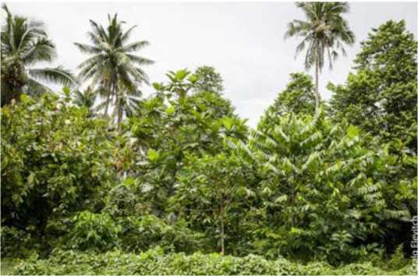countries - but particularly for the atoll countries of South Pacific atoll countries Tuvalu and Kiribati). Mature coconut palms (> 3 years to approx. 60 years) are identified as one of the most climate resilient food crops. However, after the age of a palm exceeds some 60 years, it becomes senile with low production and highly vulnerable to destruction by cyclones. If a replanting program is successfully implemented it would provide for the future availability of coconuts. Coconuts are most important and climate resilient food security crop for atoll countries.

**An agro forestry block built around coconuts and breadfruit and incorporating other traditional food crops**

In addition, the felled senile coconuts would a

provide the substantial biomass supply

needed to produce sufficient quality compost facilitating that is required for the significant production of other food crops. The outer core of the palm can be used as a source of high-quality hardwood that is particularly scarce in the atoll countries. This would provide suitable material for producing long lasting above ground planter boxes for introduced fruit and vegetable crops

Substantial public sector (donor) investment is required to implement this recommendation. Labour for the replanting program will need to be mainly supplied by the unemployed youth on Funafuti. Funding for their wages will be required. These youth, where possible, should have originated from the island where the replanting program was being conducted. This would provide an ideal opportunity to provide appropriate training in agriculture and be an encouragement for them to return to utilise their own land. Considerable investment in equipment is required. Specifically designed chain saws are needed to fell the senile palms, which have a particularly hard outside layer. Digging equipment is needed to remove the wide spreading surface roots of the senile palms. These roots need to be removed if the productivity of the land is to be restored. Substantial holes need to be dug then filled with compost (sourced from the soft inner core of the old tree) for the new plantings. Small nurseries would need to be established for the coconut, breadfruit, and other tree crop planting material

For Tuvalu coconut palm rehabilitation program should commence with the maintenance of the existing Funafuti and Nukufetau agroforestry sites. These should be then utilized as effective demonstrations for new agroforestry sites. Appropriate quality agroforestry training material now needs to be developed and made readily available to the land owners who have agreed to participate in the coconut replanting/agroforestry program. There is a need to directly involve the island Kaupule in the implementation and necessary awareness programs.

* 1. Onsite training in traditional agriculture - with a focus on the youth living in the outer islands

With the rapid loss of traditional knowledge this needs to commence as a matter of urgency with an initial pulaka pit cropping systems. The reported success achieved on Nunamea with the involvement of youth in the pulaka pit cropping provides an important starting point. Nunamea should be used as a “hands on” onsite training location for youth from other islands that still have functioning pulaka pits. Every effort needs to be made to make this training “interesting and exciting “and emphasising the basic soil science principles that are involved. The incentive provided by organized competitions between farmers and farming groups has a track record of success in Tuvalu and need to be incorporated into the training program. The training program would need to be facilitated and implemented through the participating island Kaupole at each location. Appropriate training material needs to be produced and full use should be made of experienced current and retired Dept. Ag. staff - including the highly experienced former Director of Agriculture.

* 1. Training in traditional food preservation and appropriate “modern” food processing methods

This training should be delivered through utilizing NGOs such Live and Learn, the Community Service Organision and women’s organizations. The well documented material written by Susan Parkinson provides a valuable resource that needs to be utilized**[34]**. The emphasis of “modern” processing training should be on coconut and breadfruit products. Appropriate products include: food grade copra oil, vco, coconut toddy syrup and jam, breadfruit chips and breadfruit flour. Experienced expertise available in the Pacific Islands region should be utilized. The services of food technologist Dr Richard Beyer from Fiji would be particularly suitable for this work. Appropriate training material needs to be developed and made readily available to end users. Support should also be provided for the commercial development of these products - including labelling, packaging and advice on accessing the necessary appropriate processing equipment. This support should be channelled through the Tuvalu Private Sector Organization (TPSO***)***

* 1. A concerted effort to test and distribute the climate resilience of available root crop germplasam provided through SPC.

A considerable amount of so-called “salinity tolerant”planting material has been made available through SPC CePaCT to Tuvalu and Kiribati. However, insufficient resources have been devoted to the germplasam’s evaluation and distribution. Germplasam is most effectively evaluated for both yield and taste preference when it is put in the “hands of” farmers. The success of the approach of “letting the farmers decide” has been demonstrated in Vanuatu with a proactive response to the risk taro leaf blight**[35]**. This approach needs to be adopted in the testing of “salinity tolerant” root crop and other germplasam that has been developed by SPC CePaCT.

* 1. A concerted effort to promote home garden production on Funafuti

Due to population pressure and land availability, the emphasis on Funafuti needs to be home gardens for household food security. It is not realistic to try and develop the commercial production of introduced fruit and vegetables. There is probably more scope for developing “commercial” growers on west Tarawa Kiribati somewhat more land is available for farming. The home garden approach should be based on building on the success already achieved by a number of home gardeners. These success stories should be utilised as demonstrations in “hands on” training programs. A number of these home gardeners have expressed a willingness to be involved in such demonstrations The training needs to be undertaken collaboratively between the Dept of Ag, Live and Learn NGO and TTM

Appropriate inputs need to be made readily available for home gardeners. Such inputs include: shade cloth; appropriate containers for above ground planting - including timber from felled senile coconut palms; the core of senile felled coconut palms for compost; and, appropriate fertiliser that contains the necessary trace elements). These inputs are in addition to the quality fruit and vegetable seedlings now provided by TTM. An existing retail store should be encouraged and assisted to carry a small stock of appropriate farm input supplies

Further development of appropriate training material on backyard gardening and composting in an atoll environment is required. This should build on what has been initiated by Live and Learn. The scope of the training should be expanded to include: the planting in used bags fuel drums; utilizing felled senile coconut palms (the soft core for compost and the hard-outside layer to build planting boxes) and the use of sea weed for making compost.

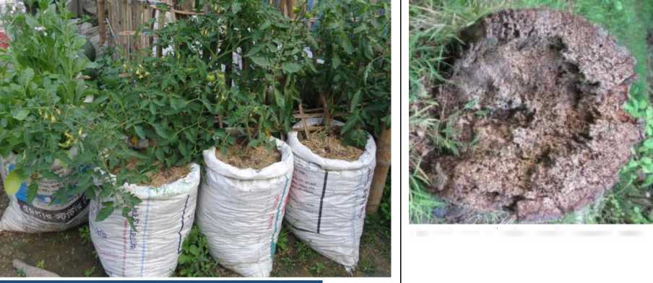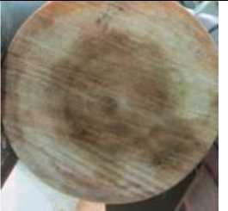

**The soft core of felled senile coconut palm**

**Growing tomatoes in used polypropylene bags that are widely available in Tuvalu.**

**The outer layer of old palm comprises particularly hard quality timber40**

* 1. Development of a viable sustainable value chain for outer island producers to sell their products (particularly root crops) in Funafuti

A concerted effort is required to promote the “Go Local” program as outlined, in the Government endorsed Tuvalu Agricultural Strategic Marketing Plan (TASMP) 2016 - 2025. Particular measures recommended from this assessment are described on page 57 above. These would be facilitated through the Tuvalu National Private Sector Organization (TNPSO***).***

* 1. Undertaking an agriculture and food production census for Tuvalu and Kiribati

Tuvalu has never had an Agriculture Census. Fortunately, some data on food production could be obtained from the 2012 Population Census and the 2015/2016 Household Income and Expenditure Survey (HIES). For Kiribati reliance had to be placed on the 2006 HIES. However, the data available was overall inadequate and dated. For adequate planning purposes, in a changing environment, both countries are in urgent need of an agriculture and food production (this would include agriculture, livestock, fisheries and handicrafts) census. FAO is the appropriate organization to fund and organize such a Census. Ideally, the Census in both atoll countries should be conducted at the same time.

40 See McGregor and Tawake (2018) “ The Coco Veneer Value Chain: The Fiji Case Study. The Coconut Industry Development Project for Pacific (CIDP). SPC/EU (in press)

1. The Food Import Capability Index (FICI), developed by FAO, is used an aggregate measure of a country’s food
2. security.. The FICI is the ratio of food imports to total mercantile exports. The premise on which the FICI has been established is that a country’s food security depends on its ability to both produce and buy food.
3. Foliaki, S; Pearce, N; (2003) Prevention and control of diabetes in Pacific people. BMJ, 327 (7412). pp. 437-9. ISSN 1468­

   5833 DOI: <https://doi.org/10.1136/bmj.327.7412.437>
4. Per Com Itaia Lausaveva former Tuvalu Director of Agriculture
5. McGregor AM and McGregor IKL (1999) Disasters and Agriculture in the Pacific Islands. RAS/92/360. United Nations Disaster Management Programme - South Pacific Office (UNDMP-SPO), Suva, Fiji.
6. Data collected by McGregor and McGregor (1999) illustrate the variability that is experienced between atolls: The southern islands of Tuvalu average more than 3000 mm a year while the drier northern islands average around 2500 mm-considerably more than Tarawa in Kiribati (1500 mm), the Southern Gilberts (less than 1000 mm), Northern Gilberts (2,000 mm), Banaba (known to drop to 200 mm), Christmas Island (875 mm) and Ujelang in the Marshalls (2030 mm) (p, 68).
7. Foale M and Harries H (2011) (revised) Farm and Forestry Production and Marketing Profile for Coconuts (Cocos nucifera). In: CR Elevitch (ed) Speciality Crops for Pacific Islands Agroforestry. Permanent Agriculture Resources, Holualoa, Hawaii, 1-24.
8. Sairusi Bulai (2017) “Converting Logs from Senile Coconut Palms into High Quality Veneer” presentation to the CIDP Regional Value Chain Workshop, Nadi Fiji July 11-13, 2017
9. Massal, E. and Barrau, J., 1954. Pacific subsistence crops: Breadfruit. SPC Quart Bull 4(4)
10. Goodman RA (1972) Plants and Man in Samoa. *Pacific Discovery* 25, 12-18.
11. Ragone D (1997) Breadfruit, Artocarpus altilis (Parkinson) Fosberg. International Plant Genetic Resources Institute, Rome, Italy. Ragone D (2006) Artocarpus altilis (breadfruit). Pp. 85-100 in Traditional Trees of Pacific Islands: Their culture, environment and use. CR Elevitch (ed.). Permanent Agriculture Resources, Holualoa, Hawaii.
12. FAO (2010) Pacific Food Security Toolkit. Building Resilience to Climate Change. Root Crop and Fishery Production, FAO, Rome, Italy.
13. McGregor Andrew and Stice Kyle. Breadfruit Market and Marketing in the Pacific Island with a focus on Fiji and Samoa. February 2018 SPC, Suva.

    [https://pafpnet.spc.int/attachments/article/855/Pacific%20Island%20Breadfruit%20Market%20and%20Marke](https://pafpnet.spc.int/attachments/article/855/Pacific%20Island%20Breadfruit%20Market%20and%20Marketing%20Final%20Report%20(March%202018)_final.pdf) [ting%20Final%20Report%20(March%202018) final.pdf](https://pafpnet.spc.int/attachments/article/855/Pacific%20Island%20Breadfruit%20Market%20and%20Marketing%20Final%20Report%20(March%202018)_final.pdf)
14. Clarke T (1992) The effect of a cyclone on crops. Journal of South Pacific Agriculture 1, 66-76.
15. Elevitch CR and Wilkinson KM (2000) *Agroforestry Guides for Pacific Islands*. Permanent Agriculture Resources, Holualoa, Hawaii.
16. <http://www.pestnet.org/SummariesofMessages/Crops/Fruitsnuts/Breadfruit/Trunkrot,Kiribati.aspx>
17. Wild relatives of breadfruit and hybrid cultivars may be more tolerant of salinity than A. altilis (Ragone 1997). ‘Mejwaan’, a seeded variety of the Marshall Islands, is not harmed by brackish water or salt spray. In Kiribati, the seeded variety ‘Te Maitairika’ has shown tolerance to saline conditions and the seedless variety ‘Te bukiraro’ may be more susceptible to salinity than the seeded varieties. Preliminary data under laboratory conditions indicate that the Samoan Ma’afala has some salinity tolerance. Research is currently being undertaken by at the Hawaii Breadfruit Institute (BFI) and the University of British

    Columbia to understand salt tolerance and exclusion; and select and propagate salt-tolerant varieties (Ragone pers. comm.).
18. Susumu G, Wichep J and Silbanuz M (2009) *Preliminary Damage Assessment (PDA) Report*. Federated States of Micronesia, Agricultural Damage Report.
19. Webb A (2007) Tuvalu Technical Report: Assessment of salinity of groundwater in swamp taro *(Cyrtosperma chamissonis)* “pulaka” pits in Tuvalu. EU-EDF8-SOPAC Project Report 75. SOPAC Secretariat, Suva, Fiji.
20. Thomson LAJ and Thaman RR 2006a *Pometia pinnata* (tava). In: CR Elevitch (ed) *Traditional trees of Pacific Islands: their culture, environment and use*. Permanent Agriculture Resources, Holualoa, Hawaii, pp. 591-606.
21. Calvert G (2011) *An assessment of tree susceptibility and resistance to cyclones - with particular reference to Severe Tropical Cyclone Yasi in Townsville on 2nd February 2011.* Report prepared for Townsville City Council and Ergon Energy, Greening Australia, Norman Park, Queensland. 138 pp.

    Similarly, breadfruit, taro, and pulaka are sliced, cooked in the umu, dried, then soaked when needed for eating. In sterile conditions, these staples can last for two to three years. To ensure sterility, these foods are stored in airtight biscuit tins which are thoroughly boiled before use. Clean tongs, are used to remove each piece of food when needed; touching the food is discouraged. An additional method is used for pulaka. The root is grated raw then dried and stored according to the methods used above. When needed, it is cooked in coconut cream. This also has a shelf life of two to three years. Puddings are made from the taro, pulaka and breadfruit (known as *solotaro, solopulaka, and solomei*, in Tuvalu). These are made by pounding up the crop and mixing it with flour or arrowroot starch (known locally as vatia). These are heavily sweetened with either toddy or sugar, which prevents them from being attacked by bacteria, and then cooked in an umu or any form of oven. This food typically has a lifetime of six to eight months, but has been known to last for up to a year. Pululeti is another example of preservation by sweetening. This is grated coconut mixed with toddy, boiled till thick and rolled into balls. If packed in sealed, sterilised containers, it can last for up to five years. The traditional place to store these foods was in the roof rafters, in woven baskets, which allows the food to be continuously sterilised by smoke and hot air from the hearths. The advent of biscuit tins and other modern containers has made this practice disappear, as they are more convenient and, if they are properly sterilised, can provide better storage capabilities. As well, pulaka can be buried for up to three months and then removed and cooked in the normal way when needed. Fulaka is kept alive while buried and does not start decaying as it would above ground. These labour-intensive foods are rarely made on Funafuti, for imported rice and tinned meats are relatively cheap and store well. Most households have at least one wage earner. Also, two-thirds of households of Funafuti are people from other islands who have no access to land, nor, therefore, to the large surpluses of crops that usually spur people to preserve food. On the outer islands,
22. FAO 2014, Round table on the double burden of malnutrition, FAO Regional Conference for Asia and the Pacific, 32nd Session, Ulaanbaatar, Mongolia, March 10-14 2014. FAO 2014, Dietary patterns of households in Samoa: Identifying the factors and food items most important to understanding nutrition, Apia, Samoa
23. <http://pubdocs.worldbank.org/en/942781466064200339/pacific-possible-health.pdf>
24. WHO/SPC (2011) Ninth Meeting of the Ministers of Health for Pacific Island Countries . Honiara, Solomon Island June 2011.
25. Xiaohui Hou, Ian Anderson, Ethan-John Burton-Mckenzie (2016). Pacific Possible: Health & Non­Communicable Diseases. Background Paper. World Bank, July 2016.
26. Chan, J. C. N., Cho, N. H., Tajima, N., & Shaw, J. (2014). Diabetes in the Western Pacific Region e past, present and future. Diabetes Research and Clinical Practice, 103, 244-255.
27. Ragone, D., & Raynor, B. (2009). Breadfruit and its traditional cultivation and use on Pohnpei. In M. J. Balick (Ed.), Ethnobotany of pohnpei. University of Hawaii Press, ISBN 978-0-8248-3293-3.
28. World Health Organization (WHO). (2010). Bulletin of the World Health Organization: Pacific islanders pay heavy price for abandoning traditional diet. World Health Organization. Electronic Document <http://www.who.int/bulletin/volumes/88/7/10-010710/en/>
29. <http://www.healthdata.org/sites/default/files/files/policy_report/2019/GBD_2017_Booklet.pdf>
30. Turi Christina E., Ying Liu, Diane Ragone, Susan J. Munch (2015). Breadfruit (Artocarpus altilis and hybrids): A traditional crop with the potential to prevent hunger and mitigate diabetes in Oceania: Review. Trends
31. Andrew McGregor and Moses Pelomo. The Solomon Islands Quality Copra Pil Value Chain for the Domestic Market. Coconut Development for the Pacific (CIDP), EU/SPC. 2018.

    <http://lrd.spc.int/reportspublications/doc_download/2484-solomon-islands-coconut-value-chain-study>
32. The is how the “Fiji Red” variety was developed. Hawaii solo sunrise was first secured from the University of Hawaii. Natures Way Cooperative, then through the bagging of flowers on the most productive trees that had the sweetest fruit in Fiji conditions seed was selected. After several generations the “Fiji red variety” was then obtained. This “certified seed can now be purchased from Natures Way Cooperative. Fiji is free of devastating disease papaya ring spot virus.
33. See McGregor et.al. A Review of the Tutu Rural Training Centre Course. December 2018

    [https://lrd.spc.int/pafnet-publications/doc_download/1701-tutu-rural-training-center-lessons-in-non-formal- adult-education-for-self-employed-in-agriculture](https://lrd.spc.int/pafnet-publications/doc_download/1701-tutu-rural-training-center-lessons-in-non-formal-adult-education-for-self-employed-in-agriculture)
34. Susan Parkinson. The Preservation and Preparation of Root Crops and Some Other Traditional Foods in the South Pacific. FAO/SPC Suva 1984
35. McGregor A, Kaoh P, Tuioti Mariner L, Lal PN and Taylor M (2011) Assessing the social and economic value of germplasm and crop improvement as a climate change adaptation strategy: Samoa and Vanuatu case studies. A background case study prepared for P. Lal (ed) Climate Change Adaptation in the Pacific: Making Informed Choices. Australian Department of Climate Change and Energy Efficiency (DCCEE), IUCN, Suva, Fiji.